**GYM MANAGEMENT SYSTEM**

**A Project Report**

Submitted in partial fulfilment of the

Requirements for the award of the Degree of

###### BACHELOR OF SCIENCE (INFORMATION TECHNOLOGY)

BY

**YADAV AMIT KAKASO & GHADGE ROHAN DILIP**

Seat Number – 41 & 14

**Under the esteemed guidance of**

**Prof Prajakta Patil**



**DEPARTMENT OF INFORMATION TECHNOLOGY**

**F. G. NAIK COLLEGE OF ARTS, COMMERCE**

###### AND

**SCIENCE (IT)**

***(Affiliated to University of Mumbai)***

**NAVI MUMBAI, 400709 MAHARASHTRA**

**2021-22**

**PERFORMA FOR THE APPROVAL PROJECT PROPOSAL**

***(Note: All entries of the Performa of approval should be filled up with appropriate and complete information. Incomplete Performa of approval in any respect will be summarily rejected.)***

PNR No. Roll No**:** 41 & 14

1. Name of the Student: -

YADAV AMIT KAKASO & GHADGE ROHAN DILIP

1. Title of the Project: -

Gym Management System

1. Name of the Guide: -

Prof. Mrs. PRAJAKTA PATIL

1. Teaching experience of the Guide
2. Is this your first submission? Yes No

Signature of the Student Signature of the Guide

Date: . Date:

Signature of the Coordinator

Date: .

**F. G. NAIK COLLEGE OF ARTS, COMMERCE AND SCIENCE (IT)**

***(Affiliated to University of Mumbai)***

**NAVI MUMBAI- MAHARASHTRA-400709**

**DEPARTMENT OF INFORMATION TECHNOLOGY**



**CERTIFICATE**

This is to certify that the project entitled, "**Gym Management**”, is bonafied work **YADAV AMIT KAKASO** and GHADGE ROHAN DILIP bearing seat number – Submitted in partial fulfilment of the requirements for the award of degree of BACHELOR OF SCIENCE in INFORMATION TECHNOLOGY from University

of Mumbai.

**Internal Guide Coordinator**

**External Examiner**

**Date: College Sea**

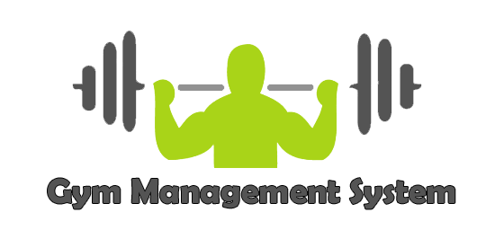

Report OF Gym Management System

ABSTRACT

Online Gymnasium Management is a beneficial website for people as well as businesses. Gym management motivates users to engage with a variety or appraise offers to spend their money sensibly. In this pandemic situation, people are willing to do gym workouts by seeing online portals. In order to provide an online gym, this particular website works on it and moreover here people can find shopping of gym types of equipment. We designed a website by using MySQL for the database backend. The gymnasium Management system can handle all the required and tiny details simply and accurate info security consequently to the users. Once login user can see the payment option after billing user can unlock the videos access and shopping of gym equipment is free for all users. This project determination effort on MySQL and full-stack used for gymnasium management.

As we know computerization can be helpful as means of saving time and money, we designed a system by using SQL for database backend and NetBeans for frontend which will provide a better graphical user interface. The gymnasium Management system can handle all the required and minute details simply and correct info security consequently to the user. They require software, which will store data about members, employees, machines, salary, diet of members etc. and lock-up with graphical user interface(GUI). The system will Check validity of information provided by user, Stores information of members according to their id, and Generate reports for different id. The projected system is very secured, as a result of for login the system it needs the username and watchword that is completely different for every department thus providing each department a special read of the member data. It additionally provides wide selection of sure criteria in every window the shopper is functioning for higher and faster answer. It maintains report for all criteria. Manages member data individually for all exercise and worker data individually for considering the wants of gymnasium, stores data regarding regular machines. This system can run on any windows operating system.

Gym Management System is an online service that can be setup for your gym to help manage classes, memberships, receive payments (merchant and cash), keep track with detailed statistics, customer management, surveys and it even has an online store so you can sell products to your customers.

* Its simple, it’s effective and it’s the way customers want their gym!
* Here is our feature list which is continually growing:
* Manage customers
* Manage customer health question forms
* Manage customer surveys
* Screenshot of Customer Options
* Complete site statistics (graphs) membership lists
* Screenshot of User Statistics graphs
* Complete payment statistics with downloadable content to excel and
* Export functions; to download customer details to create mailing lists,
* databases…
* Manage your trainers and class schedules.
* Class management
* Create recurring classes and class types
* Create multiple locations and trainers
* Create plans & passes
* Manage customer barcode/RFID/membership cards for customers.
* Customers can see their own statistics and payment history.

Gym Management System is fitness centres to operate the members in an easier way. The administrator, is able to view all the members of fitness centre as well as their details. The basic module of the system as follows. This project is a online based program and it manages the gym members, the personal and the admin. This system also maintains the student’s details, to provide the valuable reports regarding the progress of the gym member.

Acknowledgement

This project itself is an acknowledgement to the efforts of many individuals who have contributed to it. We got lot of guidance from the various people at various stages of the project development.

I respect and thank to our Principal **MR. PRATAP MAHADIK**, for providing me an opportunity to do the project work in **F. G. NAIK COLLEGE** and giving us all support and guidance, which made me complete the project duly. I am extremely thankful to her for providing such a nice support and guidance, although she had busy schedule managing the corporate affairs.

I owe my deep gratitude to our project guide **PROF. Mrs. PRAJAKTA PATIL & PROF.**

**Mrs. SMRITIGANDHA BIDKAR**, who took keen interest on our project work and guided us all along, till the completion of our project work by providing all the necessary information for developing a good system.

I am thankful to and fortunate enough to get constant encouragement, support and guidance from all Teaching staffs of Information Technology department which helped us in successfully completing our project work. Also, I would like to extend our sincere esteems to all staff in laboratory for their timely support.

DECLARATION

I hereby declare that the Project entitled, “Hostel Management System” done at **F. G. Naik college of Arts, Commerce, Science (IT)**, has not been in any case duplicated to submit to any other university for the award of any degree. To the best of my knowledge other than me, no one has submitted to any other university.

The Project is done in partial fulfilment of the requirements for the award of degree of **BACHELOR OF SCIENCE (INFORMATION TECHNOLOGY)** to be submitted as final semester project as part of our curriculum.

Yadav Amit Kakaso &

Ghadge Rohan Dilip

Name and Signature of the Student

TABLE OF CONTENTS

**Chapter1: Introduction**

1.1 Background

1.2 Objectives

1.3 Purpose, Scope, and Applicability

1.4 Achievements

**Chapter 2: Survey of Technologies**

2.1: Introduction to Android

2.2: Features And Specification

2.3: Technologies used for Admin-end Web Application

2.4: Software and Hardware Requirements

2.4.1: Software Requirements

2.4.2: Hardware Specification

**Chapter 3: Requirement And Analysis**

3.1: Problem Definition

3.2: Software Requirement Analysis

3.3: Requirement Specification

3.4: Planning And Scheduling

3.5: Software And Hardware Requirements

3.6: Conceptual Model

**Chapter 4: System Design**

4.1: Module Division

4.2: Data Dictionary

4.3: ER Diagram

4.4: DFD/UML Diagrams



**1.Introduction**

We all know health is wealth. We do not need a fancy car, big apartment, a doctor degree without a health. Being healthy is a first thing we need to keep in mind. Because most of time our attitude depends on how we feel. Being healthy and fit gives us energy to do anything. Physical fitness is very necessary for a healthy and tension free life. Physical fitness includes diet, exercise and sleep. These three basic things have their own importance in each individual's life and everyone should be sensible with regard to these for a healthy life.

A gymnasium, also known as a gym, is a covered location for [athletics](https://en.wikipedia.org/w/index.php?title=Athletic_(physical_culture)&action=edit&redlink=1). The word is derived from the [ancient Greek](https://en.wikipedia.org/wiki/Ancient_Greek) [gymnasium](https://en.wikipedia.org/wiki/Gymnasium_(ancient_Greece)). They are commonly found in athletic and [fitness](https://en.wikipedia.org/wiki/Physical_fitness) centres, and as activity and [learning spaces](https://en.wikipedia.org/wiki/Learning_space) in educational institutions. "Gym" is also slang for "[fitness centre](https://en.wikipedia.org/wiki/Fitness_centre)", which is often an area for indoor recreation. A gym is a place with a number of [equipment's](https://en.wikipedia.org/wiki/Equipment) and [machines](https://en.wikipedia.org/wiki/Machine) used by the people to do exercises. A gym may be open air as well.

Gymnasia apparatuses such as barbells, jumping board, running path, tennis-balls, cricket field, and fencing area are used as exercises. In safe weather, outdoor locations are the most conducive to health. gyms were popular in ancient Greece. Their curricula included self-defence, gymnastics medica, or physical therapy to help the sick and injured, and for physical fitness and sports, from boxing to dancing to skipping rope.

Gymnasia also had teachers of wisdom and philosophy. Community gymnastic events were done as part of the celebrations during various village festivals. In ancient Greece there was a phrase of contempt, "he can neither swim nor write." after a while, however, Olympic athletes began training in buildings specifically designed for them community sports never became as popular among ancient romans as it had among the [ancient Greeks](https://en.wikipedia.org/wiki/Ancient_Greece). Gyms were used more as a preparation for military service or spectator sports. During the [roman empire](https://en.wikipedia.org/wiki/Roman_Empire), the gymnastic art was forgotten. In the [dark ages](https://en.wikipedia.org/wiki/Dark_Ages_(historiography)) there were sword fighting tournaments and of [chivalry](https://en.wikipedia.org/wiki/Chivalry); and after [gunpowder](https://en.wikipedia.org/wiki/Gunpowder) was invented sword fighting began to be replaced by the sport of [fencing](https://en.wikipedia.org/wiki/Fencing), as well as schools of dagger fighting and wrestling and boxing.

Worldwide there has been a large shift towards less physically demanding work and a more [sedentary lifestyle](https://en.wikipedia.org/wiki/Sedentary_lifestyle). This has been accompanied by increasing use of mechanized transportation, [automobile dependency](https://en.wikipedia.org/wiki/Automobile_dependency), a greater prevalence of labour saving technology in the home, and less active [recreational pursuits](https://en.wikipedia.org/wiki/Recreational_pursuits). At least 31% of the world's population does not get sufficient [physical exercise](https://en.wikipedia.org/wiki/Physical_exercise). This is true in almost all developed

and developing countries, and among children. Some experts refer to sitting as "the new smoking" because of its negative effects on overall health.

These exercise trends are contributing to the rising rates of chronic diseases including: [obesity](https://en.wikipedia.org/wiki/Obesity), [heart disease](https://en.wikipedia.org/wiki/Heart_disease), [stroke](https://en.wikipedia.org/wiki/Stroke) and [high cholesterol](https://en.wikipedia.org/wiki/High_cholesterol). Active transport (walking, bicycling, etc.) has been found to be inversely related to obesity in Europe, North America, and Australia. Thus exercise has been associated with a decrease in mortality.

We all know for human being health is a most important thing and being healthy is first thing that we keep in our mind. Being healthy and fit gives us power to do anything, anywhere. Physically good health is very important for stress free life. Each person takes proper diet, proper exercise, proper sleep for healthy and happy life. These three things are most important for despise free life. Everyone should clever about our health because for healthy and proper life and life is so precious. The aim of the project is to designed and developed the automated system i.e. machine work. An exercise machine is any [machine](https://en.wikipedia.org/wiki/Machine) used for physical [exercise](https://en.wikipedia.org/wiki/Exercise). These range from simple spring-like devices to computerized electromechanical devices to recirculating-stream swimming pools. Most exercise machines incorporate an ergometer. An ergometer is an apparatus for measuring the [work](https://en.wikipedia.org/wiki/Mechanical_work) a person exerts while exercising as used in training or [cardiac stress tests](https://en.wikipedia.org/wiki/Cardiac_stress_tests) or other medical tests.

Exercise equipment is any apparatus or device used during [physical activity](https://en.wikipedia.org/wiki/Physical_activity) to enhance the strength or conditioning effects of that exercise by providing either fixed or adjustable amounts of resistance, or to otherwise enhance the experience or outcome of an exercise routine .Exercise equipment may also include such wearable items as proper [footgear](https://en.wikipedia.org/wiki/Athletic_shoe), [gloves](https://en.wikipedia.org/wiki/Weightlifting_gloves), and [hydration packs](https://en.wikipedia.org/wiki/Hydration_pack) .

In early system records are kept in the gym by writing in a file on a paper or it will register. Every management task is done manually. Present system is unreliable fir keeping accurate records. Gym website will help to generate the reports of various operations performed in the gym. Payment of fees, list of members who did not paid fees. This will also help for creating batches may be of particular trainers. By this system paper less work can be done easily. This will help members as well as administration.

Major benefits of this system are -

1. Increasing transparency

2. Easy payment options online digital payment etc.

3. Standardization of the system

4. Timetable of the batches online

5. Online registration

6. Maintaining about equipment in the gym it's purchased.

The "Gym Website" has been developed to override the problems prevailing in the practicing manual system. This software is supported to eliminate and, in some cases, reduce the hardships faced by this existing system. Moreover, this system is designed for the particular need of the company to carry out operations in a smooth and effective manner.

The application is reduced as much as possible to avoid errors while entering the data. It also provides error message while entering invalid data. No formal knowledge is needed for the user to use this system. Thus, by this all it proves it is user-friendly. Gym website as described above, can lead to error free, secure, reliable and fast management system. It can assist the user to concentrate on their other activities rather to concentrate on the record keeping. Thus, it will help organization in better utilization of resources.

Every organization, whether big or small, has challenges to overcome and managing the information of trainer, facility, time slot, fitness class. Every gym website has different gym needs therefore we design exclusive employee management systems that are adapted to your managerial requirements. This is designed to assist in strategic planning, and will help you ensure that your organization is equipped with the right level of information and details for your future goals. Also, for those busy executives who are always on the go, our systems come with remote access features, which will allow you to manage your workforce anytime, at all times. These systems will ultimately allow you to better manage resources.

The purpose or objective of this system is to digitalize and create an automated system. The system will perform the task like adding the new member to the gym, Removing the member or keeping the payments records and other stuff required in managing the gym properly. The present scenario in the gyms is that the records are kept by writing in a file on paper. Every management task is done manually.

This creates a system unreliable and confusing to keep the correct track of the records. The maintenance of a system like this is hardly required until it needs to change any part of the system. The information about the various things contained in the system are like members, trainers, the equipment can get by just a few clicks unlike the paper documents required the serious reading for such information.

It helps in creating the various batch according to their preference or if they want a particular trainer. It made it easy to generate the reports of various operations performed in the gym are like paying the fee it can be stored and later evaluated and get the list of members who did not pay the fee. It also helps the users in reducing the carbon footprint as the amount of paper used in the company reduces.

This also helps in keeping the standard width of the management system as if there is a case where the administration involves more than one person to manage the gym. This system does not only limit itself to the administration and but also helps the members of the gym. The members can have options like fee payment, change batch request etc.

This will improve the transparency between the members which is always a good quality in the system. It will also give a layer of security to the administration and the users that only authorized users can access by their credentials.

**1.1. Background**

The website to be produced is on Gym system. Here there are 2 users. They are the admin and the receptionist (gym instructor). Receptionist can add the details of a person who wish to join the gym. Their personal information including weight, height and phone number are collected. The receptionist also provides timings for that person, when he can come to the gym. As soon as that particular person arrives, his day of attendance will be marked by the receptionist. The receptionist can also note down the gym equipment he wishes to join.

Admin has more authority than the receptionist. He provides unique username and password for the receptionist. He also has the right to delete or modify it. He even has the authority to add the gym equipment’s to the software. He can also modify it. Finally, when that person wishes to leave the gym, his/ her present weight and height will be compared to his old height and weight. He can even store the details of the medicine information which are in the gym warehouse. He can even buy it from other medical shop and can store in the database so that any information needed can be retrieved easily.

Gathering Data: -

The initial step of the project is to collect information they wanted to store. After gathering data the work is to identifying the user needs and prioritize the need of the customer and adopt them in the system.

Study of the existing system: -

Then studied the working of current system and noted the limitation of that which motivates to make a new system. This help in the evaluating of the problems from allocating functions to system.

Feasibility study: -

For the detailed investigation, the survey is expanded to a feasibility study. Feasibility study is a done to test the system proposed according to its workability, impact, ability to meet the user needs and effective use of the resources

Proposed System Functionality: -

At last, the functionality of the proposed system is examined. Studying both existing and proposed system so that the merits and demerits of both the systems can be understood. After understanding the requirements for the new system, the drawbacks of the existing system are figure out.

Client Prospective

The system that has been used till now has the website where they can get the information about the fitness centre. According to the client, they need the system that store the information about each member, employee, and responsibility of each staff and generate a report weekly and monthly.

Following are the steps taken during the initial study. Initially all the information which they wanted to store.

**1.2. Objective**

* Easy to use and efficient computerized system.
* To develop an accurate and flexible system, it will eliminate data redundancy.
* Computerization can be helpful as means of saving time & money.
* To provide better graphical user interface.
* Accessing Membership will provide you special benefits.
* Members need to be able to book classes, pay for memberships and manage their gym

schedule.

* Online registration of the member.
* The proposed system is expected to be faster than the existing system.
* Less chances of information leakage.
* Provides security to data by using login & password.
* Provides the searching facilities based on various factors. Such as Gym, Member, Facility, Fitness Class.
* Issuing the timetable of batch on the system.
* Increase transparency between stakeholders.
* Easy payment options.
* Standardization of the system
* To maintain the health and wellness of the member.
* To provide the variety of exercise program to encourage to make changes for the healthier lifestyle.
* To provide individual attention to members encouraging wellness through fitness testing, evaluations, health screenings, exercise programming, and personal training instruction.
* To provide security to data by using login and password.
* To generate reports for different id.
* The software is capable enough to allow the concerned person to store and retrieve any type of record with just a single click of mouse. The software allows Interactive, Self-describing graphic user interface environment where even standalone users can work very comfortably and easily.
* All the data pertaining to transactions or other important entities is kept at central database from where its attributes can be easily controlled. But, such kind of technical details are hidden from the

standalone user. He just needs to type in correct details of the given entity and then click the save button with the help of mouse. However, that central repository of data can be easily accessed if required.

* Data Redundancy is no more the problem now. The data modified from one particular data entry form will reflect the modifications at the other related forms too. This has thus reduced the chances of data inconsistency in our data storage.
* There is no need to manage bulky registers now as data stored in the backend database can be radially retrieved either from the frontend form itself or directly from the database.
* Requires one time investment of setting up required hardware and software after which no more headache is required by the Managers. Moreover, it also reduces dependence on Man Power.
* Effective Search measures are present at each and every data transactional form from where by just entering a Unique keyword for that data its whole records can be readily seen within microseconds. Moreover facility of updating and deletion of data through search is also available.

The main objective of the project on gym website is to manage the details of gym, trainer, member, facility, fitness class. It manages all the information about gym, time slot, fitness class, gym. The project is totally built at administrative end and thus only the administrator is guaranteed the access. The purpose of the project is to build an application program to reduce the manual work for managing the gym, trainer, time slot, member. It tracks all the details about the member, facility, fitness class.

**1.3. Purpose, Scope and Applicability**

1. **1.3.1. Purpose**

* Accuracy in work.
* Easy & fast retrieval of information.
* Well-designed reports.
* Decrease the load of the person involve in existing manual system.
* Access of any information individually.
* Work becomes very speedy.
* Easy to update information

The purpose of gym website is to automate the existing manual system by the help of computerized equipment and full-fledged computer software, fulfilling their requirements, so that their valuable data/information can be stored for a longer period with easy accessing and manipulation of the same. The required software and hardware are easily available and easy to work with.

Gym website, as described above, can lead to error free, secure, reliable and fast management system. It can assist the user to concentrate on their other activities rather to concentrate on the record keeping. Thus, it will help organization in better utilization of resources. The organization can maintain computerized records without redundant entries. That means that one need not be distracted by information that is not relevant, while being able to reach the information.

The aim is to automate its existing manual system by the help of computerized equipment and full-fledged computer software, fulfilling their requirements, so that their valuable data/information can be stored for a longer period with easy accessing and manipulation of the same. Basically, the project describes how to manage for good performance and better services for the clients.

In other words, we can say that our website has the following qualities: -

* Pages that load in two seconds or less
* A design that displays well on mobile devices. Be sure to avoid clutter, keep things simple, easy to navigate and focused on getting visitors to click your call-to-action.
* Secure hosting platform (SSL) to make sure your visitor’s information is safe
* To increase efficiency with reduced cost.
* To reduce the burden of paper work.
* To save time management for recording details of each and
* every member and employee.
* To generate required reports easily.

People visiting your website need to know if you have a good gym. It's not enough to simply state "we are the best gym in town." instead, you must show that you are the best through published reviews. Add a page to your website that touts your gym's amazing benefits via a compilation of Facebook, google plus, reviews. The page should also give visitors a chance to leave a review of your gym and training services. However, one word of caution, make sure that you can read customer reviews before they are published on your site to avoid being spammed by people who have never been to your gym.

In this modern world, computer becomes more and more popular and important to our society. We can use computer everywhere and they are very useful and helpful to our daily life. Like computers online websites has a crucial role in the daily life. Now we have the facility to know about anything in the world through the various sites in a single click. So here we aimed to develop a site based on Gymnasium for the people who wish to maintain their health and body fitness regularly. Gym website allows the user to store employee details, the details of person who is in the gym, gym equipment details etc. This software package allows storing the details of all the data related to a gymnasium. The newly developed site for Gymnasium is more suited than the manual database because it provides the facilities like, large storage capacity, high speed, more accuracy and high security

This tool is basically developed to aid the user to add a member to the gym. The user shall be able to add the name, date of birth and contact address of the member. It also records the phone numbers and the height and weight data of the member. It shall have the admission date. It also has an option to check whether the member is new or an existing one. It stores the photo of the member. It shall help the user to know about fee payments. It has the option to select type of fee payments. It could be monthly, quarterly or annually depending on the choice of the member. It also holds the receipt number and the amount of fees paid. It shall also generate reports based on the payment of fees. It shall also enable the user to update information of members.

One of the biggest reasons for having a gym website is to help your business get discovered by those performing searches on Google. Make sure your gym website has the following key SEO components:

* Unique title tags and meta descriptions on every page.
* An XML sitemap
* Professional URL – websites ending in .com are seen more creditable than those ending in .net or .biz. Additionally, you don’t want anything long or hard to remember.
* A blog to add fresh content to your site. Google loves blog content and your members will benefit from this content as well.

Finally, a few things that don’t fall into their own category but are still really important for every site to have include:

* Pages that load in two seconds or less.
* A design that displays well on mobile devices. Be sure to avoid clutter, keep things simple, easy to navigate and focused on getting visitors to click your call-to-action.
* Secure hosting platform (SSL) to make sure your visitor’s information is safe.

**1.3.2. Scope**

It may help collecting perfect management in details. In a very short time, the collection will be obvious, simple and sensible. It will help a person to know the management of passed year perfectly and

vividly. It also helps in current all works relative to Gym website. It is an online service that can be setup for your gym to help manage classes, memberships, receive payments (merchant and cash), keep track with detailed statistics, customer management, surveys and it even has an online store so you can sell products to your customers. It will be also reduced the cost of collecting the management & collection procedure will go on smoothly.

Before your belt out for any software, it’s important to **weigh its pros and cons against your business goals.** If it doesn’t help you meet those goals either directly or indirectly, move on and find another tool that[fits your needs](https://business.virtuagym.com/blog/how-to-find-the-best-fitness-management-software/). The last thing you want is to [end up with a surplus of software](https://business.virtuagym.com/blog/ways-to-save-your-business-from-software-surplus/). That said, the advantages of a gym management system are manifold; in this blog, we will break down some popular gym management system features and their uses.

Building and running a gym involves **hard work, time, and endless upkeep of processes.**You have to manage staff schedules, onboard clients, find new leads, and ensure that your fitness center is always up to scratch. You also need a competent team to run classes and tools to track member attendance and collect fees, send out invoices, pause contracts, retain members, automate marketing flows – and that’s just the tip of the iceberg. This is where robust gym management system features come in. Such **software helps us simplify**our member management and reduce hours of back-end tasks.

Our project aims at Business process automation, i.e., we have tried to computerize various processes of Gym website.

* In computer system the person has to fill the various forms & number of copies of the forms can be easily generated at a time.
* In computer system, it is not necessary to create the manifest but we can directly print it, which saves our time.
* To assist the staff in capturing the effort spent on their respective working areas.
* To utilize resources in an efficient manner by increasing their productivity through automation.
* The system generates types of information that can be used for various purposes.
* It satisfies the user requirement
* Be easy to understand by the user and operator
* Be easy to operate
* Have a good user interface
* Be expandable
* Delivered on schedule within the budget.
* Storing information of members, employees.
* Check validity of information provided by user.
* Storing information of members according to their id.
* Generating reports for different id.
* It’s simple, it’s effective and it’s the way customers want their gym!
* Here is our feature list which is continually growing:
* Manage customers
* Manage customer health question forms
* Manage customer surveys
* Screenshot of Customer Options
* Complete site statistics (graphs) membership lists
* Screenshot of User Statistics graphs
* Complete payment statistics with downloadable content to excel and

csv file format.

* Export functions; to download customer details to create mailing lists,

databases…

* Manage your trainers and class schedules.
* Class management
* Create recurring classes and class types
* Create multiple locations and trainers
* Create plans & passes
* Manage customer barcode/RFID/membership cards for customers.
* Customers can see their own statistics and payment history.
* The main objective of the project is to design and develop a user friendly efficient computerized Gym Management System.
* An accurate system without any data redundancy
* Secured data storage for Authority end.
* Secure the user ends data by providing each user’s own personal credentials.
* A flexible system which can makeover the customer-staff relationship in an effective manner.
* To provide better graphical user interface.
* Computerization can be helpful as means of saving time & money

This document is the only one that describes the requirements of the system. It is meant foe the use by the developers, and will also the basis for validating the final delivered system. Any changes made to the requirements in future will have to go through a formal change’s approval process. The developer is responsible for asking clarifications where necessary and will not make any alterations without the permissions of the client.

1. **1.3.3. Applicability**

* Performance: System should be able handle multiple users at a time using

any of the web browsers.

* Reliability: Database updating should follow transaction processing to avoid

data inconsistency.

* Availability: The project will be deployed on a public shared server so it will

be available all the time and will be accessible anywhere of the world using

internet.

* Security: We have implemented a lot of security mechanism to avoid to hack

the system by outer world.

* Maintainability: It is very easy to maintain the system. The system has been

developed on HTML so anyone who has the knowledge of HTML, can easily

maintain the system

* Portability: Yes, this system is portable and we can switch the servers very

easily.

* Browser Compatibility: The project being web based required compatibility

with at least the popular web browsers. Microsoft Windows XP and above,

Linux and Macintosh being the current popular operating system and

Microsoft Internet Explorer, Mozilla Firefox, Opera, Safari and Google Chrome

being the currently popular web browser.

* Site Content :- All materials, including all images, software, text and graphics, design, fonts, video, audio, icons, buttons, keywords, metatags and as well as the general "look and feel" (the Site Content) contained on the Site are owned by Gym & Fitness and/or its licensors and are protected by copyright under national laws and international treaties.
* Purpose :- The Site Content is supplied to you for personal information, entertainment and education purposes only. We do not represent or warrant that the information accessible via the Site is accurate, complete or current. You will not, nor will you allow any third party, to adapt, alter or create a derivative work from any of the Site Content or use it for any other purpose other than for your personal non-commercial use.
* Lawful use :- You agree to use the Site only for lawful purposes, and in a manner which does not infringe the rights of, or restrict or inhibit the use and enjoyment of the Site by any third party. These restrictions or inhibitions include conduct which is unlawful, or which may harass or cause distress or inconvenience to any person and the transmission of obscene or offensive content. Any other use requires our prior written permission.
* Breach :- Breach of the Terms may constitute breach(es) of Gym & Fitness or its licensors' intellectual property rights, and Gym & Fitness or its licensors may be required to take legal action to protect these rights. Gym & Fitness accepts no liability for the information and imagery provided by third parties.
* Communications. If you send any communications or materials to the Site by electronic mail or otherwise, all such communications will, to the extent not otherwise labelled, be treated as non-confidential and non-proprietary. 6.Conduct. You must not post or transmit through the Site any defamatory, threatening, obscene, harmful or pornographic material or material which would violate or infringe in any way the rights of others (including, but not limited to intellectual property rights, rights of confidentiality, or rights of privacy) or cause distress or which do not comply with all relevant laws. You must not express opinions that are vulgar, crude, sexist, racist or otherwise offensive. We expect you to always treat other users with respect.

This website allows interactive, self-describing graphic user interface environment where users can work very comfortably and easily. It will be simple in design and to implement. It requires low system resources and the system will work in almost all configurations. It will be highly secured because of the login system that requires the username and password which is different for each department, therefore providing each department. It maintains report for all criteria and transactions. It manages member information separately for all exercise and employee information separately for considering the requirements of fitness. Stores the information about the services. Retrieval and updating tasks can be performed much faster and easier.

The entity of gym management system (cgms) will be the parent entity in hierarchy admin the owner of the gym will manage both the trainer and the member of the gym. There may be more than one

admins. Login system is designed to secure the system from hacking and all etc. Admin will have separate username and password log in time or log out time of the user from the system will also be recorded. Admin event also come under surveillance because of the maintaining the record of the time. The administration must have control over every entity and track every performance of the system.

1. **1.4. Achievements**

It is always necessary to study and recognize the problems of existing system, which will help in finding out the requirements for the new system. System study helps in finding different alternatives for better solution. The project study basically deals with different operations and steps involved in generation of examination mark sheets. In the gym website, if we take the current system and compare it with the proposed it is far behind. Every work in the existing is manual and done on paper. There might be a computer used somewhere for the work but it’s is not doing exactly what it’s is supposed which is reducing the manual work.

Entering everything manually to the computer by creating a file is not exactly what we are talking about in computerization. The existing system requires a lot of manual work which results in taking more time than it should. The operations like updating and synchronizing data are also done manually in the existing system that is not automated and again time-consuming process.

These practices are not at all reliable as the one wrong entry can take a lot of time in detection and then there is a correction. Humans are prone to errors and can mistakes often unless it has some inbuilt programs which can take check the input and save from error. We introduced the system to reduce the manual work effectively as there is the backend of the system which will take care of synchronizing and updating the data for the system.

So, if there is any change in the system data it will appear to all other users of the system. As the system was not online the member cannot see their timeline that the event generated by them in past such as fee payment, attendance, batch timing, and trainer profile, etc. Keeping an automated system is also helps in managing the member’s information secure and safe.

As it can only be seen by the administrator with the correct credentials which is not an option in the existing system. Unless the records are kept in a physically safe location such as a locker.

To includes:

1. Data gathering

2. Study of existing system

3. Analysing problem

4. Studying various documents

5. Feasibility study for further improvements

Following are the steps taken during the initial study:

Initially, we collected all the information, which they wanted to store. Then we studied the working of the current system which is done manually. We noted the limitation of that system which motivated them to have new system. With the help of these documents, we got basic ideas about the system as well as input output of the developed system. The first task was identifying how system can be computerized. Some

analysis and projections were done regarding changes to be made to

1. the existing system.

The old manual system was suffering from a series of drawbacks like

* Existing system was manual.
* Time consuming as data entry which include calculations took lot of time.
* Searching was very complex as there could be 100’s of entry every year.
* The proposed system is expected to be faster than the existing system.
* The Project was made in order to effectively and efficiently cater to requirements of the fitness centre. Very frequently the person who generally holds the tasks to manage the centre needs to keep records of all the transactions as well as data manually. Generally, in order to structure these tasks Separate Registers are maintained. This whole process thus becomes quite cumbersome for them to control manually. Moreover, any wrong data entered mistakenly can brings serious results.
* This manually managed system of the store was also heavily pruned to data loss due to certain causes misplacement of registers, destruction of registers, unauthorized access to registers etc. Which can bring in disastrous consequences.
* The cost of maintained of data and records of occurrence of transactions is very high.
* Searching a particular data specific to particular requirements is also very tedious in such system. In order to retrieve records, The responsible person needs to manually locate the appropriate register and locate the appropriate placement of that particular record which may be very time consuming.
* Data Redundancy is also a great issue in such kind of system. “Redundancy” means repetition; Thus, data modified or updated at a particular place may not be data modified or updated at the other related place which may create inconsistencies in data handling, Destroys Data Integrity and creates confusion for the owner.
* Required a lot of paperwork and the process takes time.
* Everything is done on paper and these are highly prone to damages and require a good amount of security and space to store.
* Required Buying of goods more frequently as compared to the online system e.g.: paper, pen.
* Likely to have an error.
* Lack of storage space for handwritten documents.
* Require more physical work and manpower.
* Information is not available globally to both clients and employees hence location restriction.

### 1. Strong Online Presence

The COVID-19 pandemic has forced many people to live a more digital way of working and living. From homeworking to digital fitness, the online world is key to moving forward. Being able to adapt and take advantage of new online opportunities is crucial to success.

we made a strong online presence so that potential members can find us  [81% of people search online for a product or service](https://www.smartinsights.com/search-engine-marketing/search-engine-statistics/). Part of a strong online presence is a fully mobile-optimized website. We have made it as easy as possible for customers to find you.

### 2. Increased Revenue and Credibility

A good website makes us look credible and trustworthy. It shows that we are qualified, professional, and ready to engage with our membership base. Our expertise is evident, and this helps us to build your authority.

At the same time, a website can be a significant driver in increasing revenue. A great website is more likely to convert visitors into paying members. For example, a quick Google search for a home fitness streaming platform may land potential customers on your website. If it’s straightforward and easy to navigate, they can sign up quickly and immediately start using your services.

### 3. Customers expect a website

Nowadays, customers expect you to have a website. Our website affects how people perceive the quality and credibility of your business. It takes about [50 milliseconds for our users to form an opinion](https://www.sweor.com/firstimpressions) of our website. That’s how long it takes for them to decide whether they stick around or go elsewhere.

For some reason if we had a poorly designed website on mobile, [57% of users wouldn’t recommend](https://www.sweor.com/firstimpressions) your business. The customer expectation is to not only have a website but to have a responsive and compelling website with a crisp layout and design.

### 4. Win in Search Results

Our website can help customer to attract new facilities through search results. An SEO-optimized website can help us rank for several terms on Google and attract a steady flow of potential customers.

While there are plenty of factors involved with ranking in search engine results, simply having a website opens up to more opportunities. When our incorporate search engine optimization into our website, we can attract more traffic, rank higher, and ultimately convert more leads than your competition.

### 5. Great Member Experience

The member experience involves every aspect of our business. It includes our interactions with staff members, the quality of your facilities, your digital fitness platform, and more. Going forward, many businesses are operating a hybrid business model. The lines between digital and in-person services are blurring. This means that the digital experience is just as important as the experience our members have in-person. A great website promotes a great member experience. Our website is home to all class schedule and member portal. Something as simple as easy booking and automated class reminders adds to the overall experience and leave members feeling good about our brand.

**SURVEY OF TECHNOLOGIES**

**2.1 TECHNOLOGIES USED FOR USER-END ANDROID APPLICATION: -**

Introduction to Android

The **Android operating system** is the largest installed base among various mobile platforms across the globe. Hundreds of millions of mobile devices are powered by **Android** in more than 190 countries of the world. It conquered around **75%**of the global market share by the end of 2020, and this trend is growing bigger every other day. The company named **Open Handset Alliance** developed Android for the first time that is based on the modified version of the Linux kernel and other open-source software. **Google**sponsored the project at initial stages and in the year 2005, it acquired the whole company. In September 2008, the first Android-powered device launched in the market. Android dominates the mobile OS industry because of the long list of features it provides. It’s user-friendly, has huge community support, provides a greater extent of customization, and a large number of companies build Android-compatible smartphones. As a result, the market observes a sharp increase in the demand for developing Android mobile applications, and with that companies need smart developers with the right skill set. At first, the purpose of Android was thought of as a mobile operating system. However, with the advancement of code libraries and its popularity among developers of the divergent domain, Android becomes an absolute set of software for all devices like tablets, wearables, set-top boxes, smart TVs, notebooks, etc.

## 

## Features of Android

Android is a powerful operating system competing with Apple 4GS and supports great features. Few of them are listed below –

* Beautiful UI :- Android OS basic screen provides a beautiful and intuitive user interface.
* Connectivity :- GSM/EDGE, IDEN, CDMA, EV-DO, UMTS, Bluetooth, Wi-Fi, LTE, NFC and WiMAX.
* Storage:- SQLite, a lightweight relational database, is used for data storage purposes.
* Media support :- H.263, H.264, MPEG-4 SP, AMR, AMR-WB, AAC, HE-AAC, AAC 5.1, MP3, MIDI, Ogg Vorbis, WAV, JPEG, PNG, GIF, and BMP.
* Messaging :- SMS and MMS
* Web browser :- Based on the open-source WebKit layout engine, coupled with Chrome's V8 JavaScript engine supporting HTML5 and CSS3.
* Multi-touch :- Android has native support for multi-touch which was initially made available in handsets such as the HTC Hero.
* Multi-tasking :- User can jump from one task to another and same time various application can run simultaneously.
* Resizable widgets :- Widgets are resizable, so users can expand them to show more content or shrink them to save space.
* Multi-Language :- Supports single direction and bi-directional text.
* GCM :- Google Cloud Messaging (GCM) is a service that lets developers send short message data to their users on Android devices, without needing a proprietary sync solution.
* Wi-Fi Direct :- A technology that lets apps discover and pair directly, over a high-bandwidth peer-to-peer connection.
* Android Beam :- A popular NFC-based technology that lets users instantly share, just by touching two NFC-enabled phones together.

### Android Versions

### Google launched the first version of the Android platform on Nov 5, 2007. Since then, Google released a lot of android versions such as Apple Pie, Banana Bread, Cupcake, Donut, Éclair, Froyo, Gingerbread, Jellybeans, Kitkat, Lollipop, marshmallow, Nougat, Oreo, etc. with extra functionalities and new features.

Application Framework:

## The Application Framework may be a set of services that together kind the surroundings during which mechanical man applications run and are managed. This framework implements the construct that mechanical man applications are made from reusable, interchangeable and replaceable elements. This concept is taken a step more in this associate application is additionally able to publish its capabilities alongside any corresponding information in order that they will be found and reused by other applications.

## Android Applications

Android applications are usually developed in the Java language using the Android Software Development Kit. Once developed, Android applications can be packaged easily and sold out either through a store such as Google Play, SlideME, Opera Mobile Store, Mobango, F-droid and the Amazon Appstore.

Android powers hundreds of millions of mobile devices in more than 190 countries around the world. It's the largest installed base of any mobile platform and growing fast. Every day more than 1 million new Android devices are activated worldwide.

### **Advantages of Android Development**

* The Android is an open-source Operating system and hence possesses a vast community for support.
* The design of the Android Application has guidelines from Google, which becomes easier for developers to produce more intuitive user applications.
* Fragmentation gives more power to Android Applications. This means the application can run two activities on a single screen.
* Releasing the Android application in the Google play store is easier when it is compared to other platforms

### **Disadvantages of Android Development**

* Fragmentation provides a very intuitive approach for user experience but it has some drawbacks, where the development team needs time to adjust with the various screen sizes of mobile smartphones that are now available in the market and invoke the particular features in the application.
* The Android devices might vary broadly. So the testing of the application becomes more difficult.
* As the development and testing consume more time, the cost of the application may increase, depending on the application’s complexity and features.

**2.2 TECHNOLOGIES USED FOR ADMIN-END WEB APPLICATION: -**

**Development Tools and Technologies**

**Front End**

HTML

JAVASCRIPT

JAVASCRIPT

CSS

1. HTML:

HTML is an acronym which stands for Hyper Text Markup Language which is used for creating web pages and web applications. Let's see what is meant by Hypertext Markup Language, and Web page.

Hyper Text: HyperText simply means "Text within Text." A text has a link within it, is a hypertext. Whenever you click on a link which brings you to a new webpage, you have clicked on a hypertext. HyperText is a way to link two or more web pages (HTML documents) with each other.

Markup language: A markup language is a computer language that is used to apply layout and formatting conventions to a text document. Markup language makes text more interactive and dynamic. It can turn text into images, tables, links, etc.

Web Page: A web page is a document which is commonly written in HTML and translated by a web browser. A web page can be identified by entering an URL. A Web page can be of the static or dynamic type. With the help of HTML only, we can create static web pages.

Hence, HTML is a markup language which is used for creating attractive web pages with the help of styling, and which looks in a nice format on a web browser. An HTML document is made of many HTML tags and each HTML tag contains different content.

## HTML Versions

Since the time HTML was invented, there are lots of HTML versions in market, the brief introduction about the HTML version is given below:

**HTML 1.0 :** The first version of HTML was 1.0, which was the barebones version of HTML language, and it was released in1991.

**HTML 2.0 :** This was the next version which was released in 1995, and it was standard language version for website design. HTML 2.0 was able to support extra features such as form-based file upload, form elements such as text box, option button, etc.

**HTML 3.2 :-**  HTML 3.2 version was published by W3C in early 1997. This version was capable of creating tables and providing support for extra options for form elements. It can also support a web page with complex mathematical equations. It became an official standard for any browser till January 1997. Today it is practically supported by most of the browsers.

**HTML 4.01 :-**  HTML 4.01 version was released on December 1999, and it is a very stable version of HTML language. This version is the current official standard, and it provides added support for stylesheets (CSS) and scripting ability for various multimedia elements.

**HTML5 :-**  HTML5 is the newest version of HyperText Markup language. The first draft of this version was announced in January 2008. There are two major organizations one is W3C (World Wide Web Consortium), and another one is WHATWG( Web Hypertext Application Technology Working Group) which are involved in the development of HTML 5 version, and still, it is under development.

## Features of HTML

1) It is a very **easy and simple language**. It can be easily understood and modified.

2) It is very easy to make an **effective presentation** with HTML because it has a lot of formatting tags.

3) It is a **markup language**, so it provides a flexible way to design web pages along with the text.

4) It facilitates programmers to add a **link** on the web pages (by html anchor tag), so it enhances the interest of browsing of the user.

5) It is **platform-independent** because it can be displayed on any platform like Windows, Linux, and Macintosh, etc.

6) It facilitates the programmer to add **Graphics, Videos, and Sound** to the web pages which makes it more attractive and interactive.

7) HTML is a case-insensitive language, which means we can use tags either in lower-case or upper-case.

2 . CSS

CSS stands for Cascading Style Sheets. It is a style sheet language which is used to describe the look and formatting of a document written in markup language. It provides an additional feature to HTML. It is generally used with HTML to change the style of web pages and user interfaces. It can also be used with any kind of XML documents including plain XML, SVG and XUL.

CSS is used along with HTML and JavaScript in most websites to create user interfaces for web applications and user interfaces for many mobile applications.

## What does CSS do

* You can add new looks to your old HTML documents.
* You can completely change the look of your website with only a few changes in CSS code.

## Why use CSS

These are the three major benefits of CSS:

## 1) Solves a big problem

Before CSS, tags like font, color, background style, element alignments, border and size had to be repeated on every web page. This was a very long process. For example: If you are developing a large website where fonts and color information are added on every single page, it will be become a long and expensive process. CSS was created to solve this problem.

## 2) Saves a lot of time

CSS style definitions are saved in external CSS files so it is possible to change the entire website by changing just one file.

## 3) Provide more attributes

CSS provides more detailed attributes than plain HTML to define the look and feel of the website.

## What is JavaScript

JavaScript (js) is a light-weight object-oriented programming language which is used by several websites for scripting the webpages. It is an interpreted, full-fledged programming language that enables dynamic interactivity on websites when applied to an HTML document. It was introduced in the year 1995 for adding programs to the webpages in the Netscape Navigator browser. Since then, it has been adopted by all other graphical web browsers. With JavaScript, users can build modern web applications to interact directly without reloading the page every time. The traditional website uses js to provide several forms of interactivity and simplicity.

Although, JavaScript has no connectivity with Java programming language. The name was suggested and provided in the times when Java was gaining popularity in the market. In addition to web browsers, databases such as CouchDB and MongoDB uses JavaScript as their scripting and query language.

## Features of JavaScript

There are following features of JavaScript:

1. All popular web browsers support JavaScript as they provide built-in execution environments.
2. JavaScript follows the syntax and structure of the C programming language. Thus, it is a structured programming language.
3. JavaScript is a weakly typed language, where certain types are implicitly cast (depending on the operation).
4. JavaScript is an object-oriented programming language that uses prototypes rather than using classes for inheritance.
5. It is a light-weighted and interpreted language.
6. It is a case-sensitive language.
7. JavaScript is supportable in several operating systems including, Windows, macOS, etc.
8. It provides good control to the users over the web browsers.

## History of JavaScript

In 1993, **Mosaic**, the first popular web browser, came into existence. In the **year 1994**, **Netscape** was founded by **Marc Andreessen**. He realized that the web needed to become more dynamic. Thus, a 'glue language' was believed to be provided to HTML to make web designing easy for designers and part-time programmers. Consequently, in 1995, the company recruited **Brendan Eich** intending to implement and embed Scheme programming language to the browser. But, before Brendan could start, the company merged with **Sun Microsystems** for adding Java into its Navigator so that it could compete with Microsoft over the web technologies and platforms. Now, two languages were there: Java and the scripting language. Further, Netscape decided to give a similar name to the scripting language as Java's. It led to 'Javascript'. Finally, in May 1995, Marc Andreessen coined the first code of Javascript named '**Mocha**'. Later, the marketing team replaced the name with '**LiveScript**'. But, due to trademark reasons and certain other reasons, in December 1995, the language was finally renamed to 'JavaScript'. From then, JavaScript came into existence.

## Application of JavaScript

JavaScript is used to create interactive websites. It is mainly used for:

* Client-side validation,
* Dynamic drop-down menus,
* Displaying date and time,
* Displaying pop-up windows and dialog boxes (like an alert dialog box, confirm dialog box and prompt dialog box),
* Displaying clocks etc.

### JavaScript Example

1. **<script>**
2. document.write("Hello JavaScript by JavaScript");
3. **</script>**

Back End

MySQL:

MySQL is currently the most popular database management system software used for managing the relational database. It is open-source database software, which is supported by Oracle Company. It is fast, scalable, and easy to use database management system in comparison with Microsoft SQL Server and Oracle Database. It is commonly used in conjunction with [PHP](https://www.javatpoint.com/php-tutorial) scripts for creating powerful and dynamic server-side or web-based enterprise applications.

It is developed, marketed, and supported by **MySQL AB, a Swedish company**, and written in [C programming language](https://www.javatpoint.com/c-programming-language-tutorial) and [C++ programming language](https://www.javatpoint.com/cpp-tutorial). The official pronunciation of MySQL is not the My Sequel; it **is My Ess Que Ell**. However, you can pronounce it in your way. Many small and big companies use MySQL. MySQL supports many Operating Systems like [Windows](https://www.javatpoint.com/windows), [Linux](https://www.javatpoint.com/linux-tutorial), MacOS, etc. with C, C++, and [Java languages](https://www.javatpoint.com/java-tutorial).

MySQL is a [Relational Database Management System](https://www.javatpoint.com/what-is-rdbms) (RDBMS) software that provides many things, which are as follows:

* It allows us to implement database operations on tables, rows, columns, and indexes.
* It defines the database relationship in the form of tables (collection of rows and columns), also known as relations.
* It provides the Referential Integrity between rows or columns of various tables.
* It allows us to updates the table indexes automatically.
* It uses many SQL queries and combines useful information from multiple tables for the end-users.

## How MySQL Works?

MySQL follows the working of Client-Server Architecture. This model is designed for the end-users called clients to access the resources from a central computer known as a server using network services. Here, the clients make requests through a graphical user interface (GUI), and the server will give the desired output as soon as the instructions are matched. The process of MySQL environment is the same as the client-server model.

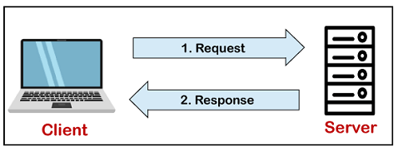

The core of the MySQL database is the MySQL Server. This server is available as a separate program and responsible for handling all the database instructions, statements, or commands. The working of MySQL database with MySQL Server are as follows:

1. MySQL creates a database that allows you to build many tables to store and manipulate data and defining the relationship between each table.
2. Clients make requests through the GUI screen or command prompt by using specific SQL expressions on MySQL.
3. Finally, the server application will respond with the requested expressions and produce the desired result on the client-side.

A client can use any MySQL [GUI](https://www.javatpoint.com/gui-full-form). But it is making sure that your GUI should be lighter and user-friendly to make your data management activities faster and easier. Some of the most widely used MySQL GUIs are MySQL Workbench, SequelPro, DBVisualizer, and the Navicat DB Admin Tool. Some GUIs are commercial, while some are free with limited functionality, and some are only compatible with MacOS. Thus, you can choose the GUI according to your needs.

## Reasons for popularity

MySQL is becoming so popular because of these following reasons:

* MySQL is an open-source database, so you don't have to pay a single penny to use it.
* MySQL is a very powerful program that can handle a large set of functionalities of the most expensive and powerful database packages.
* MySQL is customizable because it is an open-source database, and the open-source GPL license facilitates programmers to modify the SQL software according to their own specific environment.
* MySQL is quicker than other databases, so it can work well even with the large data set.
* MySQL supports many operating systems with many languages like PHP, PERL, C, C++, JAVA, etc
* MySQL uses a standard form of the well-known SQL data language.
* MySQL is very friendly with PHP, the most popular language for web development.
* MySQL supports large databases, up to 50 million rows or more in a table. The default file size limit for a table is 4GB, but you can increase this (if your operating system can handle it) to a theoretical limit of 8 million terabytes (TB).

Programming Language

PHP:

The PHP Hypertext Preprocessor (PHP) is a programming language that allows web developers to create dynamic content that interacts with databases. PHP is basically used for developing web based software applications. This tutorial helps you to build your base with PHP.

## Why to Learn PHP?

PHP started out as a small open-source project that evolved as more and more people found out how useful it was. Rasmus Lerdorf unleashed the first version of PHP way back in 1994.

PHP is a MUST for students and working professionals to become a great Software Engineer specially when they are working in Web Development Domain. I will list down some of the key advantages of learning PHP:

* PHP is a recursive acronym for "PHP: Hypertext Preprocessor".
* PHP is a server-side scripting language that is embedded in HTML. It is used to manage dynamic content, databases, session tracking, even build entire e-commerce sites.
* It is integrated with a number of popular databases, including MySQL, PostgreSQL, Oracle, Sybase, Informix, and Microsoft SQL Server.
* PHP is pleasingly zippy in its execution, especially when compiled as an Apache module on the Unix side. The MySQL server, once started, executes even very complex queries with huge result sets in record-setting time.
* PHP supports a large number of major protocols such as POP3, IMAP, and LDAP. PHP4 added support for Java and distributed object architectures (COM and CORBA), making n-tier development a possibility for the first time.
* PHP is forgiving: PHP language tries to be as forgiving as possible.
* PHP Syntax is C-Like.

## Characteristics of PHP

Five important characteristics make PHP's practical nature possible −

* Simplicity
* Efficiency
* Security
* Flexibility
* Familiarity

## Applications of PHP

As mentioned before, PHP is one of the most widely used language over the web. I'm going to list few of them here:

* PHP performs system functions, i.e. from files on a system it can create, open, read, write, and close them.
* PHP can handle forms, i.e. gather data from files, save data to a file, through email you can send data, return data to the user.
* You add, delete, modify elements within your database through PHP.
* Access cookies variables and set cookies.
* Using PHP, you can restrict users to access some pages of your website.
* It can encrypt data.

**2.3 Software and Hardware Requirements:**

**Hardware Requirements of Gym Management System**

The hardware required for the development of the project is:

* Processor: Intel P-IV System
* Processor Speed: 833 MHz
* Ram: 1 Gb Ram
* Hard Disk: 40 Gb

**Software Requirements of Gym Management System**

The software required for the development of the project is:

* Operating System: Windows 10
* Language: Visual Studio
* FRONT END : Html, CSS, java script.
* SERVER-SIDE SCRIPT : php
* DATABASE : MySQL

REQUIREMENT AND ANALYSIS

3.1. Problem Definition

Defining a problem is one of the important activities of the project. The objective is to define precisely the business problem to be solved & thereby determined the scope of the new system. This phase consist of 2 main tasks. The 1st task within this activity is to review the organization needs that originally initiated the project.

The 2nd task is to identify, at an abstract or general level, the expected capabilities of the new system. Thus, it helps us to define the goal to be achieved & the boundary of the system. A clear understanding of the problem will help us in building a better system & reduce the risk of project failure. It also specifies the resources that have to be made available to the project. Three important factors project goal, project bounds & the resource limits are sometimes called the project’s term of reference.

Time consuming as data entry which include calculations took lot of time. Searching was very complex as there could be 100’s of entry every year. The proposed system is expected to be faster than the existing system. The Project was made in order to effectively and efficiently cater to requirements of the fitness centerer frequently the person who generally holds the tasks to manage the centre needs to keep records of all the transactions as well as data manually.

Generally, in order to structure these tasks Separate Registers are maintained. This whole process thus becomes quite cumbersome for them to control manually. Moreover, any wrong data entered mistakenly can brings serious results. This Manually Managed system of the store was also heavily prone to data loss due to certain causes Misplacement of Registers, Destruction of Registers, Unauthorized access to registers etc. which can bring in disastrous Consequences.

The cost of maintenance of data and records of occurrence of transactions is very high. Searching a particular data specific to particular requirements is also very tedious in such system. In order to retrieve records, The responsible person needs to manually locate the appropriate register and locate the appropriate placement of that particular record which may be very time consuming.

Data Redundancy is also a great issue in such kind of system.” Redundancy” means repetition; Thus, data modified or updated at a particular place may not be data modified or updated at the other related place which may create inconsistencies in data handling, Destroys Data Integrity and creates confusion for the owner.

**3.1.1 Existing System**

The existing system in gyms is using paperwork and direct human language communication to manage the gym system This creates problems, in terms of member records and their transactions which minimize the overall performance of the system and do not fulfil the requirements. Thus the work becomes increase.

The existing System such as Gym Master is not as much as user (Customer) friendly as compare to our Proposed System. The communication with members is not well in Existing System because all the data is handled by Gym manager. Customers don’t get full accessibility to Gym centre and all permissions are allowed only for Gym manager. Today’s System cannot take effort out of finances and debt collection. Today’s systems are time taking software and cannot be easily install in Operating System like Linux,

Vista, Mc-OS, and Novel. And also need high configuration of PC. Normal PCs cannot install in it. Lot of memory space is required for installing existing software. Existing Gym management software cannot perform all operation expected by manager such as keeping record of machinery maintenance and service data

As the records are to be manually maintained it consumes a lot of time. Lot of paper work is involved as the records are maintained in the files & registers. As files and registers are used the storage space requirement is increased. Use of papers for storing valuable data information is not at all

reliable. As the system is in manual there are lot many chances of human

errors. These can cause errors in calculating mechanism or maintaining customer details. It is difficult for keeping all the new entries of members, their account and transaction details.

In the gym management system, if we take the current system and compare it with the proposed it is far behind. Every work in the existing is manual and done on paper. There might be a computer used somewhere for the work but it’s is not doing exactly what it’s is supposed which is reducing the manual work.

Entering everything manually to the computer by creating a file is not exactly what we are talking about in computerization. The existing system requires a lot of manual work which results in taking more time than it should. The operations like updating and synchronizing data are also done manually in the existing system that is not automated and again time-consuming process.

These practices are not at all reliable as the one wrong entry can take a lot of time in detection and then there is a correction. Humans are prone to errors and can mistakes often unless it has some inbuilt programs which can take check the input and save from error. We introduced the system to reduce the manual work effectively as there is the backend of the system which will take care of synchronizing and updating the data for the system.

So, if there is any change in the system data it will appear to all other users of the system. As the system was not online the member cannot see their timeline that the event generated by them in past such as fee payment, attendance, batch timing, and trainer profile, etc. Keeping an automated system is also helps in managing the member’s information secure and safe.

As it can only be seen by the administrator with the correct credentials which is not an option in the existing system. Unless the records are kept in a physically safe location such as a locker.

Some major drawbacks of the existing system:

* Required a lot of paperwork and the process takes time.
* Everything is done on paper and these are highly prone to damages and require a good amount of security and space to store.
* Required Buying of goods more frequently as compared to the online system e.g.: paper, pen.
* Likely to have an error.
* Lack of storage space for handwritten documents.
* Require more physical work and manpower.
* Information is not available globally to both clients and employees hence location restriction.

**3.2. Proposed System**

In the gym management system, after the planning and analysis phase of the system gets completed. Then the next phase required to transform the collected required system information into a structural blueprint which will serve as a reference while constructing the working system. It is a phase when most of the risks and errors unveiled so it’s is good practice to take care of this thing from the start.

This is a fully-fledged system that will be the backbone of the whole management of the gym so ignoring the risk or error is not an option as later it can make a greater form of itself. So, it is better to minimize the problems faced by both staff and the manager in the Organization.

Fitness Gym Management System provides a computer-based management system for keeping all records about Members, Machinery, Expenses, transactions and Salaries in an efficient and accessible database. This system helps the Owner and Admin to maintain large data about users and their daily transactions in gymnasium System is helping in creating reports, manage salaries, expenses, and machinery record.

The system is also suitable for users for an automated attendance and online profile Our Gymnasium Management System is the best option for it. It reduces and removes the manual and traditional workload; Administrator can easily add/ delete/ update/view each record on the computer.

This Gym Management System tool is basically developed to aid the user to add a member to the gym. The user shall be able to add the name, date of birth and contact address of the member. It also records the phone numbers and the height and weight data of the member. It shall have the admission date. It also has an option to check whether the member is new or an existing one. It stores the photo of the member. It shall help the user to know about fee payments. It has the option to select type of fee payments. It could be monthly, quarterly or annually depending on the choice of the member. It also holds the receipt number and the amount of fees paid. It shall also generate reports based on the payment of fees. It shall also enable the user to update information of members. This tool uses .net framework with MS Access as the database. It secures the data of each user. Storage and retrieval of data is fast through these .net tools.

The online gym management system is user-friendly application. This automated system makes all functionality easier for both owners and customers. It is very simple in design and to implement. The system requirements are very low. System resources and the system will work in almost all configurations. 5 It has the following objectives

Enhancement: The main objective of Smart Gym Management System is to enhance and upgrade the existing system by increasing its efficiency and effectiveness. The software improves the working methods by replacing the existing manual system with the computer-based system.

Automation: The Smart Gym Management System automates each and every activity of the manual system and increases its throughput. Thus, the response time of the system is very less and it works very fast.

Accuracy: The Smart Gym Management System provides the uses a quick response with very accurate information regarding the users etc. Any details or system in an accurate manner, as and when required.

User-Friendly: The software Smart Gym Management System has a very user-friendly interface. Thus, the users will feel very easy to work on it. The software provides accuracy along with a pleasant interface. Make the present manual system more interactive, speedy and user friendly.

Availability: The transaction reports of the system can be retried as and when required. Thus, there is no delay in the availability of any information, whatever needed, can be captured very quickly and easily. Maintenance cost reduce the cost of maintenance.

**3.1.3 Operating System**

Android is a [mobile operating system](https://en.wikipedia.org/wiki/Mobile_operating_system) based on a modified version of the [Linux kernel](https://en.wikipedia.org/wiki/Linux_kernel) and other [open source](https://en.wikipedia.org/wiki/Open-source_software) software, designed primarily for [touchscreen](https://en.wikipedia.org/wiki/Touchscreen) mobile devices such as [smartphones](https://en.wikipedia.org/wiki/Smartphone) and [tablets](https://en.wikipedia.org/wiki/Tablet_computer). Android is developed by a consortium of developers known as the [Open Handset Alliance](https://en.wikipedia.org/wiki/Open_Handset_Alliance) and commercially sponsored by [Google](https://en.wikipedia.org/wiki/Google). It was unveiled in November 2007, with the first commercial Android device, the [HTC Dream](https://en.wikipedia.org/wiki/HTC_Dream), being launched in September 2008.

Android is an open source and Linux-based Operating System for mobile devices such as smartphones and tablet computers. Android was developed by the Open Handset Alliance, led by Google, and other companies. Android offers a unified approach to application development for mobile devices which means developers need only develop for Android, and their applications should be able to run on different devices powered by Android.

On June 27, 2012, at the Google I/O conference, Google announced the next Android version, 4.1 Jelly Bean. Jelly Bean is an incremental update, with the primary aim of improving the user interface, both in terms of functionality and performance.

The source code for Android is available under free and open-source software licenses. Google publishes most of the code under the Apache License version 2.0 and the rest, Linux kernel changes, under the GNU General Public License version 2.

It is [free and open-source software](https://en.wikipedia.org/wiki/Free_and_open-source_software); its source code is known as Android Open Source Project (AOSP), which is primarily licensed under the [Apache License](https://en.wikipedia.org/wiki/Apache_License). However most Android devices ship with additional [proprietary software](https://en.wikipedia.org/wiki/Proprietary_software) pre-installed, most notably [Google Mobile Services](https://en.wikipedia.org/wiki/Google_Mobile_Services) (GMS).which includes core apps such as [Google Chrome](https://en.wikipedia.org/wiki/Google_Chrome), the [digital distribution](https://en.wikipedia.org/wiki/Digital_distribution) platform [Google Play](https://en.wikipedia.org/wiki/Google_Play) and associated [Google Play Services](https://en.wikipedia.org/wiki/Google_Play_Services)

About 70 percent of Android smartphones run Google's ecosystem; some with vendor-customized user interface and software suite, such as [TouchWiz](https://en.wikipedia.org/wiki/TouchWiz) and later [One UI](https://en.wikipedia.org/wiki/One_UI) by Samsung, and Sense. Competing Android ecosystems and [forks](https://en.wikipedia.org/wiki/Fork_(software_development)) include [Fire OS](https://en.wikipedia.org/wiki/Fire_OS) (developed by [Amazon](https://en.wikipedia.org/wiki/Amazon_(company))) or [Lineages](https://en.wikipedia.org/wiki/LineageOS). However, the "Android" name and logo are [trademarks](https://en.wikipedia.org/wiki/Trademark) of Google which impose standards to restrict "uncertified" devices outside their ecosystem to use Android branding.

The source code has been used to develop variants of Android on a range of other electronics, such as [game consoles](https://en.wikipedia.org/wiki/Video_game_console), [digital cameras](https://en.wikipedia.org/wiki/Digital_camera), [portable media players](https://en.wikipedia.org/wiki/Portable_media_player), [PCs](https://en.wikipedia.org/wiki/Personal_computer) and others, each with a specialized user interface. Some well-known derivatives include [Android TV](https://en.wikipedia.org/wiki/Android_TV) for televisions and [Wear OS](https://en.wikipedia.org/wiki/Wear_OS) for wearables, both developed by Google. Software packages on Android, which use the [APK](https://en.wikipedia.org/wiki/Android_application_package) format, are generally distributed through proprietary [application stores](https://en.wikipedia.org/wiki/Application_store) like [Google Play Store](https://en.wikipedia.org/wiki/Google_Play_Store), [Samsung Galaxy Store](https://en.wikipedia.org/wiki/Samsung_Galaxy_Store), [Huawei App Gallery](https://en.wikipedia.org/wiki/Huawei_AppGallery), [Cafe Bazaar](https://en.wikipedia.org/wiki/Cafe_Bazaar), and [GetJar](https://en.wikipedia.org/wiki/GetJar" \o "GetJar), or open source platforms like [Aptoide](https://en.wikipedia.org/wiki/Aptoide" \o "Aptoide) or [F-Droid](https://en.wikipedia.org/wiki/F-Droid).

**3.2 Software Requirement Analysis:**

**3.2.1 Role of SRS**

**1) Requirement Analysis**

Requirement analysis is done in order to understand the problem the software system is to solve. The problem could be automating an existing manual process, developing a new automated system, or a combination of the two. The emphasis in requirements analysis is on identifying what is needed from the system, not how the system will achieve its goals. There are atleast two parties involved in the software development-a client and a developer. The developer has to develop the system to satisfy the client’s needs. The developer does not understand the client’s problem domain, and the client does not understand the issues involved in the software systems. This causes a communication gap, which has to be adequately

bridged during requirements analysis.

**2) Software Design**

The purpose of the design phase is to plan a solution of the problem specified by the requirements documents. This phase is the first step in moving from the problem domain to the solution domain. Starting with what is needed, design takes us toward how to satisfy the needs. The design of a system is perhaps the most critical factor affecting the quality of the software. It has a major impact on the later phases, particularly testing and maintenance. The design activity is divided into two phases: System Design and Detailed Design. In system design the focus is on identifying the modules, whereas during detailed design the focus is on designing the logic for each of the modules.

**3.3 Requirement Specification:-**

**3.3.1 Feasibility Study**

Feasibility study is made to see if the project on completion will serve the purpose of the organization for the amount of work, effort and the time that spend on it. Feasibility study lets the developer foresee the future of the project and the usefulness. A feasibility study of a system proposal is according to its work ability, which is the impact on the organization, ability to meet their user needs and effective use of resources. Thus when a new application is proposed it normally goes through a feasibility study. The document provide the feasibility of the project that is being designed and lists various areas that were considered very carefully during the feasibility study of this project such as Technical, Economic and Operational feasibilities.

The first study aspect is whether the current project is technically feasible i.e. whether the project be carried out with the current equipment, existing software and available personnel. If new technology is required than what is the likelihood that it can be developed? The second study aspect is whether the project is economically feasible i.e. are there sufficient benefits in creating the system to make the cost acceptable. Are the costs of not creating the system so great that the project must be undertaken? The third study aspect is whether the project is operationally feasible or not i.e. whether the system will be used if it is developed and implemented? Project is worth developing only if it can meet institutions operating requirements.

The feasibility study proposes one or more conceptual solutions to the problem set for the project. The objective in assessing feasibility is to determine whether a development project has a reasonable chance of success. It helps us to determine the input & output of the system. The following are the criteria that are considered to confirm the project feasibility. The systems objectives outlined during the feasibility study serve as the basic from which the work of system design is initiated. Much of the activities involved at this stage is of technical nature requiring a certain degree of experience in designing systems, sound knowledge of computer related technology and through understanding of computers available in the market and the various facilities provided by the vendors.

Nevertheless, a system cannot be designed in isolation without the active involvement of the user. The user has a vital role to play at this stage too. As we know that data collected during feasibility study wills we utilized systematically during the system design. It should, however be kept in mind that detailed study of the existing system is not necessarily over with the completion of the feasibility study. Depending on the plan of feasibility study, the level of detailed study will vary and the system design stage will also vary in the amount of investigation that still needs to be done.This investigation is generally an urgent activity during the system.Sometimes, but rarely, this investigation may form a separate stage between feasibility study and computer system design.

Designing a new system is a creative process, which calls for logical as well as lateral thinking. The logical approach involves systematic moves towards the end product keeping in mind the capabilities of the personnel and the equipment at each decision making step. Lateral thought implies encompassing of ideas beyond the usual functions and equipment. This is to ensure that no efforts are being made to fit previous solutions into new situations. The feasibility study proposes one or more conceptual solutions to the problem set for the project. The objective in assessing feasibility is to determine whether a development project has a reasonable chance of success. It helps us to determine the input & output of the system. The following are the criteria that are considered to confirm the project feasibility Gym Management System feasibility is to determine whether a development project has a reasonable chance of success. It helps us to determine the input & output of the system. The following are the criteria that are considered to confirm the project feasibility Gym Management System :-

Currently, there are plenty of apps that can track your workout and show the current process

however, very few apps demonstrate how the exercises are done and devise a plan. We will

develop a mobile application based on android operating system. The motivation for this

project came from the group meeting and we discussed all of the project options available to

us. The gym project idea resonated with the team as it was applicable to each of our daily

lives and it is something we could benefit from ourselves. The main objectives of our project

is to create an app which enables the user to effectively lose weight, maintain weight and gain

muscle in a sustainable manner with clear and concise plans and videos. The project will be

scheduled around the deadlines outlined in the coursework specification, the milestones we

have developed ourselves and the problems which may arise and how quick it is overcomed.

The schedule will also depend on assigned tasks, how long they will take to complete. The

goal of the project is to develop and design an app that meets our users’ requirements.

The SRS document describes the system requirements elicitation process conducted and

identifies the requirements for the system to be developed. It should not exceed 10 pages and

it should include:

● Preface provides details on the version of the document and its revision history.

● Introduction describes the need for the system, a brief description of the system’s functions

and how it will work, similar systems and overlapping functionality.

● Glossary defines the technical terms used in the document.

● Method provides details on the method used to elicit the requirements and how you applied

this method.

● User requirements definition describes the services provided for the user. At this stage, this

description is high level, and provided using natural language and diagrams that are

understandable to a non-specialized audience.

● System requirements specification describes the functional and non-functional requirements

in details.

Examples of SRS documents available at:

● http://www.lostclouds.com/2Communicate/project/SRS.pdf http://www.artemis-

emmon.eu/deliverables/FP7-JU-EMMON-2010-DL-WP7-003-D7.1-software-requirements-

specification-document.pdf

You should view the SRS document as a contract between yourselves and the client of the

system you are developing. Please make sure you address all your users’ concerns when

writing the SRS document.

Currently, there are plenty of apps that can track your workout and show the current process

however, very few apps demonstrate how the exercises are done and devise a plan. We will

develop a mobile application based on android operating system. The motivation for this

project came from the group meeting and we discussed all of the project options available to

us. The gym project idea resonated with the team as it was applicable to each of our daily

lives and it is something we could benefit from ourselves. The main objectives of our project

is to create an app which enables the user to effectively lose weight, maintain weight and gain

muscle in a sustainable manner with clear and concise plans and videos. The project will be

scheduled around the deadlines outlined in the coursework specification, the milestones we

have developed ourselves and the problems which may arise and how quick it is overcomed.

The schedule will also depend on assigned tasks, how long they will take to complete. The

goal of the project is to develop and design an app that meets our users’ requirements.

The SRS document describes the system requirements elicitation process conducted and

identifies the requirements for the system to be developed. It should not exceed 10 pages and

it should include:

● Preface provides details on the version of the document and its revision history.

● Introduction describes the need for the system, a brief description of the system’s functions

and how it will work, similar systems and overlapping functionality.

● Glossary defines the technical terms used in the document.

● Method provides details on the method used to elicit the requirements and how you applied

this method.

● User requirements definition describes the services provided for the user. At this stage, this

description is high level, and provided using natural language and diagrams that are

understandable to a non-specialized audience.

● System requirements specification describes the functional and non-functional requirements

in details.

Examples of SRS documents available at:

● http://www.lostclouds.com/2Communicate/project/SRS.pdf http://www.artemis-

emmon.eu/deliverables/FP7-JU-EMMON-2010-DL-WP7-003-D7.1-software-requirements-

specification-document.pdf

You should view the SRS document as a contract between yourselves and the client of the

system you are developing. Please make sure you address all your users’ concerns when

writing the SRS document.

Currently, there are plenty of apps that can track your workout and show the current process

however, very few apps demonstrate how the exercises are done and devise a plan. We will

develop a mobile application based on android operating system. The motivation for this

project came from the group meeting and we discussed all of the project options available to

us. The gym project idea resonated with the team as it was applicable to each of our daily

lives and it is something we could benefit from ourselves. The main objectives of our project

is to create an app which enables the user to effectively lose weight, maintain weight and gain

muscle in a sustainable manner with clear and concise plans and videos. The project will be

scheduled around the deadlines outlined in the coursework specification, the milestones we

have developed ourselves and the problems which may arise and how quick it is overcomed.

The schedule will also depend on assigned tasks, how long they will take to complete. The

goal of the project is to develop and design an app that meets our users’ requirements.

The SRS document describes the system requirements elicitation process conducted and

identifies the requirements for the system to be developed. It should not exceed 10 pages and

it should include:

● Preface provides details on the version of the document and its revision history.

● Introduction describes the need for the system, a brief description of the system’s functions

and how it will work, similar systems and overlapping functionality.

● Glossary defines the technical terms used in the document.

● Method provides details on the method used to elicit the requirements and how you applied

this method.

● User requirements definition describes the services provided for the user. At this stage, this

description is high level, and provided using natural language and diagrams that are

understandable to a non-specialized audience.

● System requirements specification describes the functional and non-functional requirements

in details.

Examples of SRS documents available at:

● http://www.lostclouds.com/2Communicate/project/SRS.pdf http://www.artemis-

emmon.eu/deliverables/FP7-JU-EMMON-2010-DL-WP7-003-D7.1-software-requirements-

specification-document.pdf

You should view the SRS document as a contract between yourselves and the client of the

system you are developing. Please make sure you address all your users’ concerns when

writing the SRS document.

**3.3.2 Technical Feasibility**

At first it's necessary to check that the proposed system is technically feasible or not & to determine the technology and skill necessary to carry out the project. If they are not available then find out the solution to obtain them. At first, it’s necessary to check that the proposed system is technically feasible or not & to determine the technology and skill necessary to carry out the project. If they are not available then find out the solution to obtain them. Hardware is already available in the collage.

Technical feasibility centres around the existing computer system (Hardware and Software etc) and to what extend it support the proposed addition. For example, if the current computer is operating at 80 percent capacity - an arbitrary ceiling - then running another application could overload the system or require additional Hardware. This involves financial considerations to accommodate technical enhancements. If the budgets is a serious constraint, then the project is judged not feasible. In this project, all the necessary cautions have been taken care to make it technically feasible. Using a key, the display of text/object is very fast.

Also, the tools, operating system and programming language used in this localization process is compatible with the existing one. The system must be evaluated from the technical point of view first. The assessment of this feasibility must be based on an outline design of the system requirement in the terms of input, output, programs and procedures. Having identified an outline system, the investigation must go on to suggest the type of equipment, required method developing the system, of running the system once it has been designed.

Technical Gyms raised during the investigation are:

* Does the existing technology sufficient for the suggested one?
* Can the system expand if developed?

The project should be developed such that the necessary functions and performance are achieved within the constraints. The project is developed within latest technology. Through the technology may become obsolete after some period of time, due to the fact that never version of same software supports older versions, the system may still be used. So, there are minimal constraints involved with this project. The system has been developed using PHP the project is technically feasible for development.

**3.3.3 Economic Feasibility**

While considering economic feasibility, it is checked in points like performance, information and outputs from the system. MS Access is available in one package of the windows operating system & does not require additional software cost for the client tools. The cost incurred to develop the system is freeware &

does not incur the cost to the project. Backend database technology is a freeware. This justifies economic feasibility of the system. Economic analysis is the most frequently used method for evaluating the effectiveness of the candidate system. More commonly known as cost/benefit analysis, the procedure is to

be determining the benefits and savings that are expected from a candidate and compare them with costs. If benefits outweigh costs, then the decision is made to design and implement the system. A systems financial benefit must exceed the cost of developing that system. i.e. a new system being developed should be a good investment for the organization.

Economic feasibility considers the following:

i. The cost to conduct a full system investigation.

ii. The cost of hardware and software for the class of

application.

iii. The benefits in the form of reduced cost or fewer

costly errors.

iv. The cost if nothing changes (i.e. The proposed system

is not developed).

The proposed SYSTEM is economically feasible because

i. The system requires very less time factors.

ii. The system will provide fast and efficient automated environment instead of slow and error prone

manual system, thus reducing both time and man power spent in running the system.

iii. The system will have GUI interface and very less user training is required to learn it.

iv. The system will provide service to view various information if required for some decision making.

**3.3.4 Operational Feasibility**

The operational feasibility is obtained by consulting with the system users. Check that proposed solution satisfies the user needs or not. There is no resistance from employee since new system is helpful. The existing system is manual system, while the new system is computerized and extremely user friendly.

This Application is very easy to operate as it is made user friendly with the help of very effective GUI tools. Main consideration is user’s easy access to all the functionality of the Application. Another main consideration is here is that whether user organization is trained enough to use the newer application. Here every functionality is as per previous operational strategy which is not expected to be cumbersome to

the potential clients. A very easy menu system and also used some control buttons in the easy way by which one can choose the options on his desire. Though this is fully protected with the security by word (Password and user name),If both are matched only then one can get access of this software**.** Various Reports, Forms and Queries can be generated on the fingertips for the user. In nutshell we can say that it has following operational features:

1. It is User-Friendly.

2. It is having less paperwork.

3. Efficient tractability.

4. Query can be generated.

**3.3. Planning & Scheduling**

**Gantt Chart:**

The Gantt chart provided in the figure below provided a detailed description of the activities that are to be performed during the project and the estimated start time and finishing time of each of those activities (Kerzner, 2013; Meredith and Mantel Jr., 2011). In that way the project manager was able to comprehend the duration of a particular activity and the overall duration of the project (Baker, Murphy and Fisher, 2008). The Gantt chart also enabled the project manager to identify the activities that had slack or float time. This is measure of the extent to which a particular activity can be delayed.

A Gantt chart is a type of bar chart, developed by Henry Gantt, that illustrates a project schedule. Gantt charts illustrate the start and finish dates of the terminal elements and summary elements of a project. Terminal elements and summary elements comprise the work breakdown structure of the project. Some Gantt charts also show the dependency (i.e., precedence network) relationships between activities. Gantt charts are useful tools for planning and scheduling projects.

1. PROJECT PLANNING: Establish benchmarks for budget, scope, & deadline. Detect project specifications; distribute necessities into outline tasks, smaller milestones or deliverables, assessment time & available resources. Plot assignments, milestones & phases of the project against the calendar.

2. PROJECT TRACKING: Trace the work items progress after launching, such as % complete – monitor at-risk assignments & any variations from the calendar. Follow actual vs. estimates.

3. RESOURCE MANAGEMENT: Detect the appropriateness of the resource to a provided task on the basis of the expected skill set & availability. Overlook scheduling disagreements by projecting staffing requirements and inspecting only appropriate support that is accessible throughout the duration of the task.

4. TASK MANAGEMENT: Allocate tasks to users, and then users are informed to new jobs & can inspect their allotted functions as a to-do record with begin & due dates.

5. COLLABORATION: Incorporate project specifications and associates, so users are operating off of the corresponding acquaintance base on tasks, status updates, progress, and much more.

One of the best Gantt chart tools is an excel template name Gantt Chart Excel. This template allows you to plan your projects and create beautiful looking timelines in no time. The template is based on excel and it is easy to use as excel is familiar to everyone in the project team.

❖ Gantt charts allow you to assess how long a project should take.

❖ Gantt charts lay out the order in which tasks need to be carried out.

❖ Gantt charts help manage the dependencies between tasks.

❖ Gantt charts determine the resources needed.

❖ Gantt charts are useful tools when a project is under way.

❖ Gantt charts monitor progress. You can immediately see what should have been achieved at a point in time.

❖ Gantt charts allow you to see how remedial action may bring the project back on course.



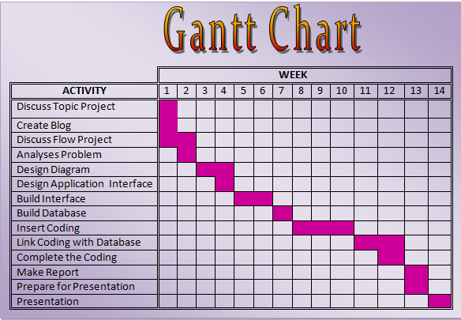

**PERT CHART**

PERT (Project Evaluation and Review Technique) Charts consist of a network of boxes and arrows. The boxes represent activity task dependencies. PERT Charts are a more sophisticated form of activity chart.

It is a visual project management tool used to map out and track the tasks and timelines. The name PERT is an acronym for Project (or Program) Evaluation and Review Technique.

There are not one but many critical paths, depending on the permutations of the estimated for each task. A critical path in a PERT Chart shown by using shaded boxes. PERT Chart incorporates additional information about the time when an engineer does a task. PERT Chart is more useful for monitoring the timely progress activities. The list of tasks and events is networked in PERT chart in above figure. The arrow length is not significant, but the sequence and interconnections must give a true picture of the precedence of activities to be completed.

The numbers on the activity lines are the time (in week) required between events. The critical path is the longest path through the network. No. task on the critical path can be held up without delaying the start of the next tasks and, ultimately, the completion of the project. So the critical path determines the project completion date.

How a PERT Chart Works :-

A PERT chart helps a [project manager](https://www.investopedia.com/articles/professionals/113015/project-manager-career-path-qualifications.asp) analyse a project's tasks and estimate the amount of time required to complete each task in the project. Using this information, the project manager can estimate the minimum amount of time required to complete the entire project. This information also helps the manager develop a [project budget](https://www.investopedia.com/terms/b/budget.asp) and determine the resources needed to accomplish the project.

A PERT chart uses circles or rectangles called nodes to represent project events or milestones. These nodes are linked by vectors or lines that represent various tasks. Dependent tasks are items that must be performed in a specific manner.

For example, if an arrow is drawn from Task No. 1 to Task No. 2 on a PERT chart, Task No. 1 must be completed before work on Task No. 2 begins. Items at the same stage of production but on different task lines within a project are referred to as parallel tasks. They're independent of each other, but they're planned to occur at the same time.

* A well-constructed PERT chart looks like this:

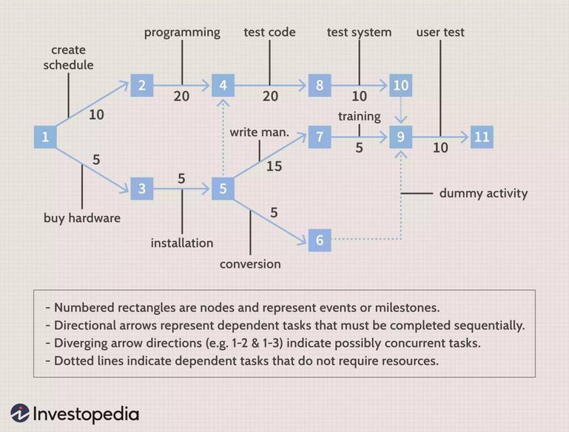

**3.4.1 SPIRAL MODEL**

The spiral model, originally proposed by Boehm, is evolutionary software process model that couples the iterative nature of prototyping with the controlled and systematic aspects of the linear sequential model. It provides the potential for rapid development of incremental versions of the software. Using the spiral model, software is developed in a series of incremental releases. During early iterations, the incremental release might be a paper model or prototype. During later iterations, increasingly more complete versions of the engineered system are produced. A spiral model is divided into a number of framework activities, also called task regions.6 typically, there are between three and six task regions. Figure depicts a spiral

model that contains six task regions:

• **Customer communication**—tasks required to establish effective communication between developer and customer.

• **Planning**—tasks required to define resources, timelines, and other project related information.

• **Risk analysis**—tasks required to assess both technical and management risks.

• **Engineering**—tasks required to build one or more representations of the application.

• **Construction and release**—tasks required to construct, test, install, and provide user support

(e.g., documentation and training).

• **Customer evaluation**—tasks required to obtain customer feedback based on evaluation of the software representations created during the engineering stage and implemented during the installation stage. Each of the regions is populated by a set of work tasks, called a task set, that are adapted to the characteristics of the project to be undertaken. For small projects, the number of work tasks and their formality is low. For larger, more critical projects, each task region contains more work tasks that are defined to achieve a higher level of formality. In all cases, the umbrella activities (e.g., software configuration management and software quality assurance) noted is applied. As this evolutionary process begins, the software engineering team moves around the spiral in a clockwise direction, beginning at the centre. The first circuit around the spiral might result in the development of a product specification; subsequent passes around the spiral might be used to develop a prototype and then progressively more sophisticated versions of the software. Each pass through the planning region results in adjustments to the project plan. Cost and schedule are adjusted based on feedback derived from customer evaluation. In addition, the project manager adjusts the planned number of iterations required to complete the software. Unlike classical process models that end when software is delivered, the spiral model can be adapted to apply throughout the life of the computer software. An alternative view of the spiral model can be considered by examining the project entry point axis, also shown in Figure. Each cube placed along the axis can be used to represent the starting point for different types of projects. A “concept development project” starts at the core of the spiral and will continue (multiple iterations occur along the spiral path that bounds the central shaded region) until concept development

is complete. If the concept is to be developed into an actual product, the process proceeds through the next cube (new product development project entry point) and a “new development project” is initiated. The new product will evolve through a number of iterations around the spiral, following the path that bounds the region that has somewhat lighter shading than the core. In essence, the spiral, when characterized in this

way, remains operative until the software is retired. There are times when the process is dormant, but whenever a change is initiated, the process starts at the appropriate entry point (e.g., product enhancement). The spiral model is a realistic approach to the development of large-scale systems and software. Because software evolves as the process progresses, the developer and customer better understand and react to risks at each evolutionary level. The spiral model uses prototyping as a risk reduction mechanism but, more important, enables the developer to apply the prototyping approach at any stage in the evolution of the product. It maintains the systematic stepwise approach suggested by the classic life cycle but incorporates it

into an iterative framework that more realistically reflects the real world. The spiral model demands a direct consideration of technical risks at all stages of the project and, if properly applied, should reduce risks before they become problematic. The spiral model is a software development process combining elements of both design and prototyping-in-stages, in an effort to combine advantages of top-down and bottom-up concepts. Also known as the spiral lifecycle model, it is a systems development method (SDM) used in information technology (IT). This model of development combines the features of the prototyping model and the waterfall model. The spiral model is intended for large, expensive and complicated projects.

**The steps in the spiral model can be generalized as follows:**

1. The new system requirements are defined in as much detail as possible. This usually involves interviewing a number of users representing all the external or internal users and other aspects of the existing system.

2. A preliminary design is created for the new system.

3. A first prototype of the new system is constructed from the preliminary design. This is usually a scaled-down system, and represents an approximation of the characteristics of the final product.

4. A second prototype is evolved by a fourfold procedure:

1. Evaluating the first prototype in terms of its strengths, weaknesses, and risks;

2. Defining the requirements of the second prototype;

3. Planning and designing the second prototype;

4. Constructing and testing the second prototype.

5. At the customer's option, the entire project can be aborted if the risk is deemed too great. Risk factors might involve development cost overruns, operating-cost miscalculation, or any other factor that could, in the customer's judgment, result in a less-than satisfactory final product.

6. The existing prototype is evaluated in the same manner as was the previous prototype, and, if necessary, another prototype is developed from it according to the fourfold procedure outlined above.

7. The preceding steps are iterated until the customer is satisfied that the refined prototype represents the final product desired.

8. The final system is constructed, based on the refined prototype.

9. The final system is thoroughly evaluated and tested. Routine maintenance is carried out on a continuing basis to prevent largescale failures and to minimize downtime.

**Applications**

The spiral model is used most often in large projects. For smaller projects, the concept of agile software development is becoming a viable alternative.

**Advantages**

• Estimates (i.e. budget, schedule, etc.) become more realistic as work progresses, because important issues are discovered earlier.

• It is more able to cope with the changes that software development generally entails. Software engineers can get their hands in and start working on the core of a project earlier.

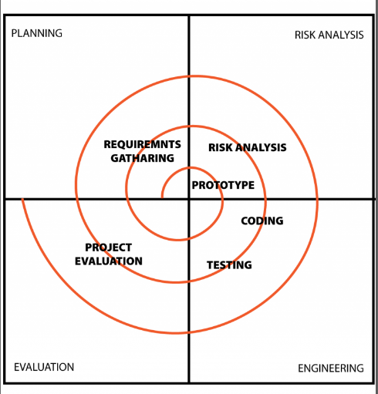

**3.4 Software and Hardware Requirements**

The necessary Hardware and Software required for the development of the proposed applications are: -

**Hardware**

* Processor Type : Pentium -IV
* Ram : 512 MB or more
* Speed : 2.4 GHZ
* Cache: 1 MB
* Hard Disk: 10 GB recommended
* Monitor - 5VGA

**Software**

* Operating System :- Windows 7/8/10

## Visual Studio Code

* Data Base: MySQL

**3.6 Conceptual Model**

**DFD:**

A data flow (DFD) is a graphical system model that shows all of the main requirements for an information system in one datagram: inputs and outputs, processes, and data storage. A DFD describes what data flows rather than how it is processed. Everyone working on a development project can see all aspects of the system working together at once with DFD. That is one reason for its popularity. The DFD is also easy to read because it is graphical model. The DFD is mainly used during problem analysis. End Users, management, and all information systems workers typically can read and interpret the DFD with minimal training. DFD is a model, which gives the insight into the information domain and functional domain at the same time. DFD is refined into different levels. The more refined DFD is, more details of the system are incorporated. In the process of creating a DFD, we decompose the system into different functional subsystems.

The DFD refinement results in a corresponding refinement of data. Following is the DFD of the “Proposed System”. We have refined the system up to two levels. Each break-up has been numbered as per

the rule of DFD. We have tried to incorporate all the details of the system but there is some chance of further improvisation because of the study that is still going on for the project development**.** We usually begin withdrawing a context diagram, a simple representation of the whole system. To elaborate further from that, we drill down to a level 1 diagram with additional information about the major functions of the system. This could continue to evolve to become a level 2 diagram when further analysis is required.

**Notations of DFD**:

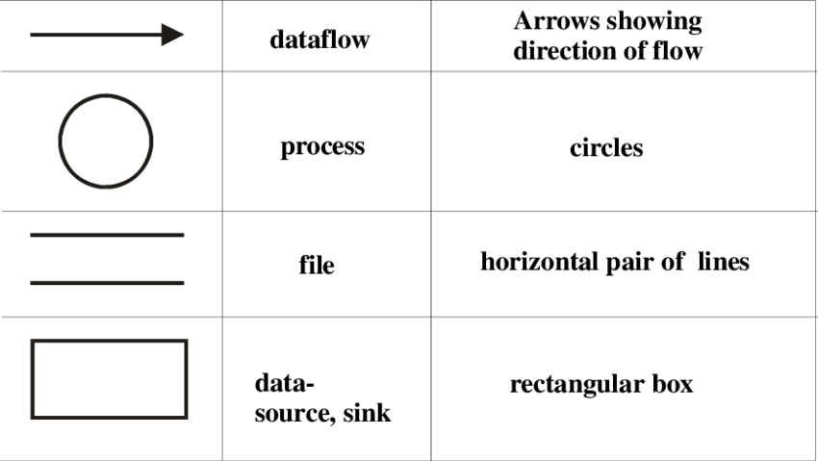

**DFD Diagram:**

**Level 0 DFD:**

.Initially in the first level of the Data flow the level 0 explains the basic outline of the system. The end-user sends the packets to the system to determine the source and destination address. The diagram marked as the 0 represents the complete Packet watching system which simply represents the basic operation that is being performed by it in the initial level. The context diagram is useful for showing boundaries. The system scope is defined by what is represented within single process and what is represented as an external agent. External agents that supply or receive data from the system are outside of the system scope. Everything else is inside the system scope. Data stores are not usually shown on the context diagram because all of the system’s data stores are considered to be within the system scope. The context diagram is simply

the highest-level DFD. It is also called as Level 0 DFD. The context diagram provides a good overview of the scope of the system, showing the system in “context” but it does not show any detail about the processing that takes place inside the system.

This is the Zero Level DFD of Gym Management System, where we have elaborated the high-level process of Gym Management. It's a basic overview of the whole Gym Management System or process being analysed or modelled. It's designed to be an at-a-glance view of Trainer, Payment and Branch showing the system as a single high-level process, with its relationship to external entities of gym, Gym Shift and Gym Facility. It should be easily understood by a wide audience, including Gym, Gym Facility and Trainer In zero level DFD of Gym Management System, we have described the high-level flow of the Gym Management system.

High Level Entities and process flow of 6ym Management System:

* Managing all the Gym
* Managing all the Gym Shift
* Managing all the Gym Facility
* Managing all the Package
* Managing all the Trainer
* Managing all the Payment
* Managing all the Branch

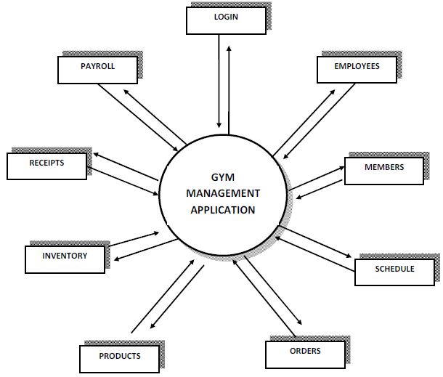

**Level 1 DFD:-**

Context diagrams are diagrams where the whole system is represented as a single process. A level 1 DFD notates each of the main sub-processes that together form the complete system. We can think of a level 1 DFD as an “exploded view” of the context diagram. You may also need some downward levelling. That is, the processes identified in the preliminary DFD may not turn out to be primitive processes and may require downward portioning into lower-level DFDs.

First Level DFD (1st Level) of Gym Management System shows how the system is divided into sub-systems (processes), each of which deals with one or more of the data flows to or from an external agent, and which together provide all of the functionality of the Gym Management System system as a whole. It also identifies internal data stores of Branch, Payment, Trainer, Package, Gym Facility that must be present in order for the Gym Management system to do its job, and shows the flow of data between the various parts of Gym, Gym Facility, Payment, Branch, Trainer of the system. DFD Level 1 provides a more detailed breakout of pieces of the ‘s level DFD. You will highlight the main functionalities of Gym Management

Main entities and output of First Level DFD (1st Level OFD):

* Processing Gym records and generate report of all Gym
* Processing Gym Shift records and generate report of all Gym Shift
* Processing Gym Facility records and generate report of all Gym Facility
* Processing Package records and generate report of all Package
* Processing Trainer records and generate report of all Trainer
* Processing Payment records and generate report of all Payment
* Processing Branch records and generate report of all Branch

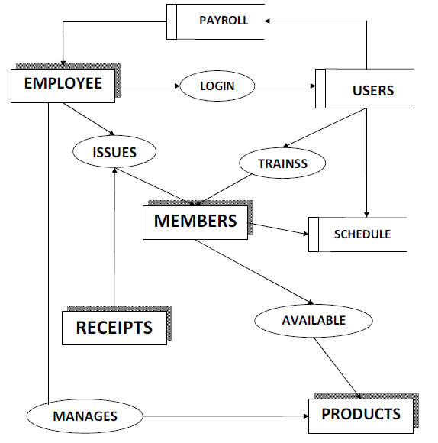

**3.7.1 ERD**

The entity-relationship (ER) data model allows us to describe the data involved in a real-world enterprise in terms of object and their relationships and is widely used to develop an initial database design.

The ER model is important primarily for its role in database design. It provides useful concepts that allow us to move from an informal description of what users want from their database to a more detailed and precise description that can be implemented in a DBMS. The ER model is used in a phase called “Conceptual Database Design”. It should be noted that many variations of ER diagrams are in use and no widely accepted standards prevail.

ER modelling is something regarded as a complete approach to design a logical database scheme. This is

incorrect because the ER diagram is just an approximate description of data, constructed through a very subjective evaluation of the information collected during requirements analysis.

**3.7.2 Entity**

ER modelling is something regarded as a complete approach to design a logical database schema. This is

incorrect because the ER diagram is just an approximate description of data, constructed through a very subjective evaluation of the information collected during requirements analysis. An entity is an object in the real world that is distinguishable from other objects. Examples include the following: The address of the manager of the institution, a Person with unique name etc. It is often useful to identify a collection of similar

entities. Such a collection is called as “Entity set”. Note that entity set need not be disjoint.

**3.7.3 Attributes**

An entity is described using a set of attributes. All entities in a given entity set have the same attributes; this essentially what we mean by similar. Our choice of attributed reflects the level of detail at which we wish to represent information in crisis. For e.g. The admission entity set would use the name, age, and qualification of the students as the attributes. In this case we will store the name, the registry no, the course enrolled of the student and not his/her address or the gender.

**3.7.4 Domain**

For each attribute associated with an entity set, we must identify a domain of possible values. For e.g. the domain associated with the attribute name of the student might be of the set of 20-character string.

Another example would be the ranking of the students in the institute would be on the scale of 1-6, the

associated domain consists of integers 1 through 6.

**3.7.5 Key**

Further, for each entity set we choose a key. A key is a minimal set of attributed whose values uniquely

identify an entity in the set. There could be more than one candidate; if so, we designate one of them as primary key. For now we will assume that each entity set contains at least one set of attributes that uniquely identify an entity in the entity set; that is the set of attributes contains a key.

**3.8 Use Case Diagram:**

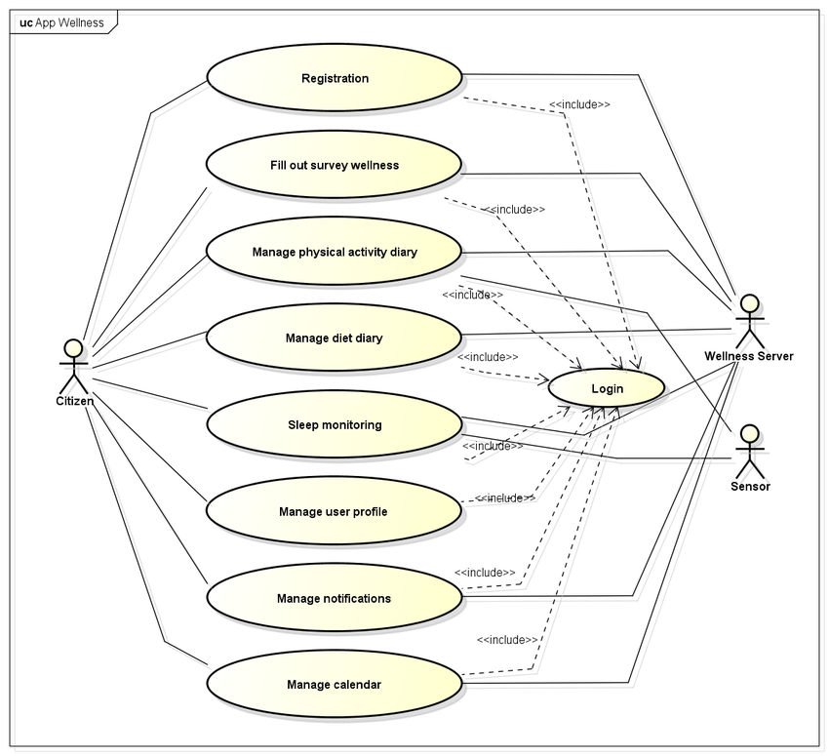

**SYSTEM DESIGN**

**4.1. Introduction to UML:**

UML (Unified Modeling Language) is a general-purpose, graphical modeling language in the field of Software Engineering. UML is used to specify, visualize, construct, and document the artifacts (major elements) of the software system. It was initially developed by Grady Booch, Ivar Jacobson, and James Rumbaugh in 1994-95 at Rational software, and its further development was carried out through 1996. In 1997, it got adopted as a standard by the Object Management Group.

UML (Unified Modeling Language) is a general-purpose, graphical modeling language in the field of Software Engineering. UML is used to specify, visualize, construct, and document the artifacts (major elements) of the software system. It was initially developed by Grady Booch, Ivar Jacobson, and James Rumbaugh in 1994-95 at Rational software, and its further development was carried out through 1996. In 1997, it got adopted as a standard by the Object Management Group.

## **What is UML**

The UML stands for Unified modeling language, is a standardized general-purpose visual modeling language in the field of Software Engineering. It is used for specifying, visualizing, constructing, and documenting the primary artifacts of the software system. It helps in designing and characterizing, especially those software systems that incorporate the concept of Object orientation. It describes the working of both the software and hardware systems.

The UML was developed in 1994-95 by Grady Booch, Ivar Jacobson, and James Rumbaugh at the Rational Software. In 1997, it got adopted as a standard by the Object Management Group (OMG).

The Object Management Group (OMG) is an association of several companies that controls the open standard UML. The OMG was established to build an open standard that mainly supports the interoperability of object-oriented systems. It is not restricted within the boundaries, but it can also be utilized for modeling the non-software systems. The OMG is best recognized for the Common Object Request Broker Architecture (CORBA) standards.

## **Goals of UML**

* Since it is a general-purpose modelling language, it can be utilized by all the modelers.
* UML came into existence after the introduction of object-oriented concepts to systemize and consolidate the object-oriented development, due to the absence of standard methods at that time.
* The UML diagrams are made for business users, developers, ordinary people, or anyone who is looking forward to understand the system, such that the system can be software or non-software.
* Thus it can be concluded that the UML is a simple modelling approach that is used to model all the practical systems.

## **Characteristics of UML**

The UML has the following features:

* It is a generalized modelling language.
* It is distinct from other programming languages like C++, Python, etc.
* It is interrelated to object-oriented analysis and design.
* It is used to visualize the workflow of the system.
* It is a pictorial language, used to generate powerful modelling artifacts.

## **Conceptual Modelling**

Before moving ahead with the concept of UML, we should first understand the basics of the conceptual model.

A conceptual model is composed of several interrelated concepts. It makes it easy to understand the objects and how they interact with each other. This is the first step before drawing UML diagrams.

Following are some object-oriented concepts that are needed to begin with UML:

* **Object:** An object is a real world entity. There are many objects present within a single system. It is a fundamental building block of UML.
* **Class:** A class is a software blueprint for objects, which means that it defines the variables and methods common to all the objects of a particular type.
* **Abstraction:** Abstraction is the process of portraying the essential characteristics of an object to the users while hiding the irrelevant information. Basically, it is used to envision the functioning of an object.
* **Inheritance:** Inheritance is the process of deriving a new class from the existing ones.
* **Polymorphism:** It is a mechanism of representing objects having multiple forms used for different purposes.
* **Encapsulation:** It binds the data and the object together as a single unit, enabling tight coupling between them.

**4.1.1UML Approach:**

**UML Diagram**

There are several types of UML diagrams and each one of them serves a different purpose regardless of whether it is being designed before the implementation **or after (as part of documentation).**

**The two most broad categories that encompass all other types are Behavioral** UML diagram and **Structural** UML diagram. As the name suggests, some UML diagrams try to analyze and depict the structure of a system or process, whereas other describe the behavior of the system, its actors, and its building components. The different types are broken down as follows:

#### **Structural UML Diagram**

* [Use Case Diagram](https://tallyfy.com/uml-diagram/#use-case-diagram)
* [Class Diagram](https://tallyfy.com/uml-diagram/#class-diagram)
* [Activity Diagram](https://tallyfy.com/uml-diagram/#activity-diagram)
* Flow Diagram

#### Use Case Diagram

A cornerstone part of the system is the [functional requirements](https://reqtest.com/requirements-blog/functional-vs-non-functional-requirements/) that the system fulfills. Use Case diagrams are used to analyze the system’s [high-level requirements](http://www.testablerequirements.com/testablerequirements/ident_hlrs.htm). This Use Case Diagram is a graphic depiction of the interactions among the elements of Gym Management System. It represents the methodology used in system analysis to identify, clarify, and organize system requirements of Gym Management System. The main actors of Gym Management ‘System in this Use Case Diagram are: Super Admin, System User, Trainer, Members, who perform the different type of use cases such as Manage Gym, Manage Gym Shift, Manage Gym Facility, Manage Package, Manage Trainer, Manage Payment, Manage Branch, Manage Users and Full Gym ‘Management System Operations. Major elements of the UML use case diagram of Gym Management System are shown on the picture below.

The relationships between and among the actors and the use cases of Gym Management System:

* Super Admin Entity : Use cases of Super Admin are Manage Gym, Manage Gym Shift, Manage Gym Facility, Manage Package, Manage Trainer,
* Manage Payment, Manage Branch, Manage Users and Full Gym Management System Operations
* System User Entity : Use cases of System User are Manage Gym, Manage Gym Shift, Manage Gym Facility, Manage Package, Manage Trainer,
* Manage Payment, Manage Branch
* Trainer Entity : Use cases of Trainer are Create Schedule, Create Diet Chart, Add Workout Plans, View Members
* Members Entity : Use cases of Members are Search Gyms, Apply for Membership, View Workouts, Make Payments

Within the circular containers, we express the actions that the actors perform. Such actions are: purchasing and paying for the stock, checking stock quality, returning the stock or distributing it. As you might have noticed, use case UML diagrams are good for showing dynamic behaviors between actors within a system, by simplifying the view of the system and not reflecting the details of implementation.

#### 

Class diagram

Gym Management System Class Diagram describes the structure of a Gym Management System classes, their attributes, operations (or methods), and the relationships among objects. The main classes of the Gym Management System are Gym, Package, Trainer, Payment, Branch, Member.

Classes of Gym Management System Class Diagram:

* Gym Class : Manage all the operations of Gym
* Package Class : Manage all the operations of Package
* Trainer Class : Manage all the operations of Trainer
* Payment Class : Manage all the operations of Payment
* Branch Class : Manage all the operations of Branch
* Member Class : Manage all the operations of Member

Classes and their attributes of Gym Management System Class Diagram:

* Gym Attributes : gym_id, gym_name, gym_type, gym_description, gym_address
* Package Attributes : package_id, package_gym_id, package_name, package_amount, package_total, package_type, package_description
* Trainer Attributes : trainer_id, trainer_gym_id, trainer_name, trainer_mobile, trainer_email, trainer_username, trainer_password, trainer_address
* Payment Attributes: payment_id, payment_customer_id, payment_date, payment_amount, payment_description
* Branch Attributes : branch_id, branch_name, branch_type, branch_city, branch_address
* Member Attributes : member_id, member_name, member_mobile, member_emall, member_username, member_password, member_address

Classes and their methods of Gym Management System Class Diagram:

* Gym Methods : addGym(), editGym(), deleteGym(), updateGym(), saveGym(), searchGym()
* Package Methods : addPackage(), editPackage(), deletePackage(), updatePackage(), savePackage(), searchPackage()
* Trainer Methods : addTrainer(), editTrainer(), deleteTrainer(), updateTrainer(), saveTrainer(), searchTrainer()
* Payment Methods : addPayment(), editPayment(), deletePayment(), updatePayment(), savePayment(), searchPayment()
* Branch Methods : addBranch(), editBranch(), deleteBranch(), updateBranch(), saveBranch(), searchBranch()
* Member Methods : addMember(), editMtember(), deleteMember(), updateMember(), saveMember(), searchMember()

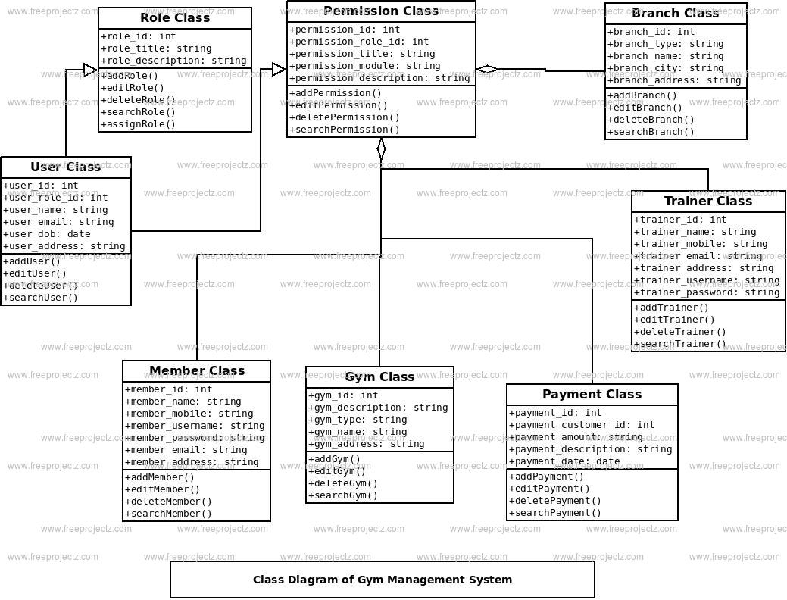

#### Activity Diagram

Activity diagrams are probably the most important UML diagrams for doing [business process modeling](https://tallyfy.com/business-process-modeling/). In software development, it is generally used to describe the flow of different activities and actions. These can be both sequential and in parallel. They describe the objects used, consumed or produced by an activity and the relationship between the different activities. All the above are essential in business process modeling.

A process is not focused on what is being produced but rather on the set of activities that lead to one the other and how they are interconnected, with a clear beginning and end. The example above depicts the set of activities that take place in a content publishing process. In a business environment, this is also referred to as [business process mapping](https://tallyfy.com/business-process-mapping/) or [business process modeling](https://tallyfy.com/business-process-modeling).

The main actors are the author, the editor and the publisher. In the diagram, you can see how the diamond shape is used to describe processes that require branching or repetitive processes, i.e: loops. In this example, one of the loops happens when the reviewer is reviewing the draft and decides that some changes need to be done. The author then revises the draft and pushes it down the pipeline again, for the review to analyze.

  Are you thinking of using Microsoft Flow to try and run approval workflows? [Think again](https://tallyfy.com/integrations/using-microsoft-flow-for-approvals/) – you will need something a lot easier for business users

This is the Activity UML diagram of Gym Management System which shows the flows between the activity of Branch, Gym, Trainer, Payment, Facility. The main activity involved in this UML Activity Diagram of Gym Management System are as follows:

* Branch Activity
* Gym Activity
* Trainer Activity
* Payment Activity
* Facility Activity

Features Of The Activity UML Diagram Of Gym Management System

* Admin User can search Branch, view description of a selected Branch, add Branch, update Branch and delete Branch.
* Its shows the activity flow of editing, adding and updating of Gym
* User will be able to search and generate report of Trainer, Payment, Facility
* All objects such as ( Branch, Gym, Facility) are interlinked
* Its shows the full description and flow of Branch, Payment, Facility, Trainer, Gym

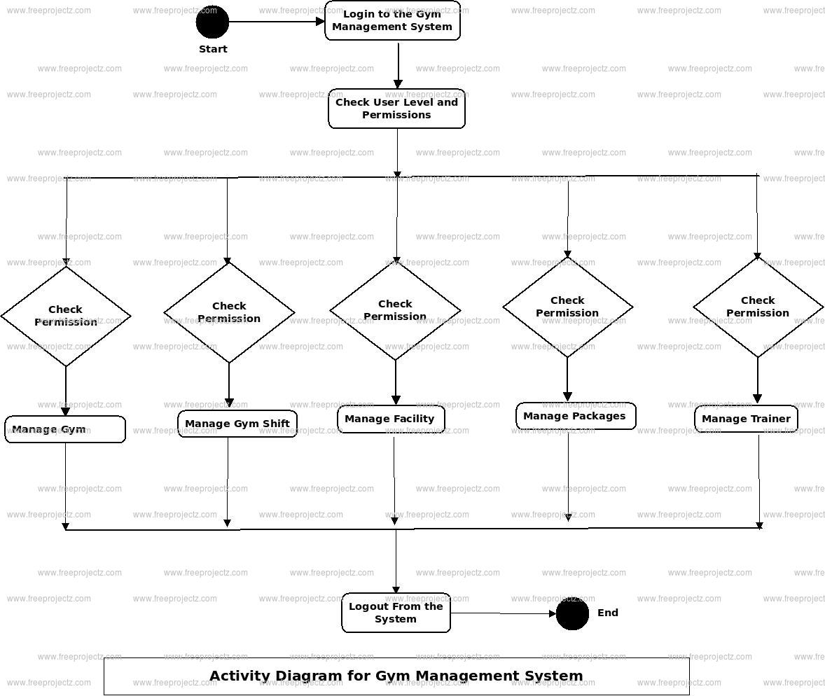

Login Activity Diagram Of Gym Management System:

This is the Login Activity Diagram of Gym Management System, which shows the flows of Login Activity, where admin will be able to login using their username and password. After login user can manage all the operations on Trainer, Branch, Gym, Facility, Payment. All the pages such as Gym, Facility, Payment are secure and user can access these page after login. The diagram below helps demonstrate how the login page works in a Gym Management System. The various objects in the Facility, Trainer, Branch, Gym, and Payment page—interact over the course of the Activity, and user will not be able to access this page without verifying their identity.

Flow Diagram

Gym Management System Data flow diagram is often used as a preliminary step to create an overview of the Gym Management without going into great detail, which can later be elaborated it normally consists of overall application dataflow and processes of the Gym Management process. It con- tains all of the user flow and their entities such all the flow of Gym, Gym Shift, Gym Facility, Package, Trainer, Payment, Branch. All of the below dia- grams has been used for the visualization of data processing and structured design of the Gym Management process and working flow.

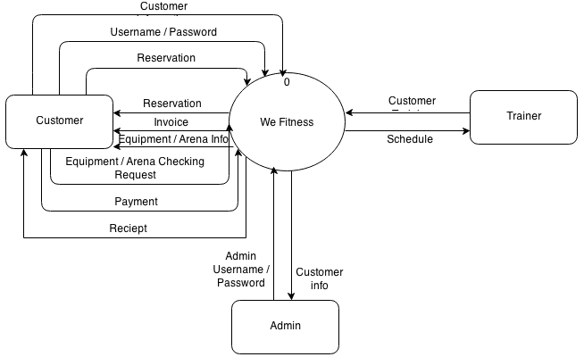

**Testing**

Testing is the major quality control measure used during software development. Its basic function is to detect errors in the software. Testing not only uncover errors introduced during coding, but also errors introduced during the previous phases. Thus, the goal of the testing is to uncover requirement, design and coding errors in the programs. Therefore, different levels of testing are used. Testing is an extremely critical and time consuming activity. It requires proper planning of the overall testing process. The output of the testing phase is the test report and the error report. Test report contains the set of test cases and the result of executing the code with these

test cases. The error report describes the errors encountered and the action taken to remove the errors.

➢ Testing is the major quality control measure used during software development. Its basic function is to

detect defects in the software. The goal of testing is to uncover requirement, design, and coding errors in the programs.

➢ The starting point of testing is unit testing, where the different modules or components are tested

individually.

➢ The modules are integrated into the system; integration testing is performed, which focuses on testing the interconnection between modules.

➢ After the system is put together, system testing is performed. Here the system is tested against the

system requirements to see if all the requirements are met and if the system performs as specified by

the requirements.

➢ Finally, the acceptance testing is performed to demonstrate to the client, on real-life data of the client, the operation of the system.

➢ Then for different test. A test case specification document is produced, which lists all the different

test cases, together with the expected outputs.

➢ The final output of the testing phase is the test report and the error report, or set of such reports. Each test report contains the set of test cases and the result of executing the code with these test cases.

System testing is designed to uncover the weaknesses that were not found in earlier test. In the testing phase, the program is executed with the explicit intention of finding errors. This includes forced system failures and validation of the system, as its user in the operational environment will implement it. For this purpose test cases are developed. When a new system replaces the old one, such as in the present case, the organization can extract data from the old system to test them on the new.

Such data usually exist in sufficient volume to provide sample listings and they can create a realistic environment that ensures eventual system success. Regardless of the source of test data, the programmers and analyst will eventually conduct four different types of tests.

Levels of Testing

❖ Unit Testing

❖ Component Integration Testing

❖ System Testing

❖ Acceptance Testing

Unit Testing

Unit testing is a level of software testing where individual units/components of a software are tested. The purpose is to validate that each unit of the software performs as designed. Unit testing comprises the set of tests performed usually by the programmers prior to the integration of the unit in to a large Program. This is the lowest level of testing and is done by the programmer (Who develops it) who can test it in great detail. The function is done in isolation. This is where the most detailed investigation of internal working of the individual unit is carried out.

Component Integration Testing

When two or more tested components are combined into a larger structure, the testing process should look for errors in two ways:-

❖ In the interface between the components

❖ The functions, which can be performed by the new group

System Testing

After in integration testing is completed, the entire system is tested as whole. The functional specifications or requirements specification are used to derive the test case. At this level the system testing looks for errors in the end-to-end functional quality. Attributes such as performance, reliability, Volume, stress tolerance, usability, maintainability, security etc. Independent testers can carry out this testing.

System testing is a level of software testing where a complete and integrated software is tested.

Acceptance Testing

After system testing was complete, the system was handed over to the training section. Acceptance testing mark the transaction from ownership by the develop to ownership by the users. The acceptance test is different in nature to the development testing in three ways. Firstly, it is a responsibility of the accepting section rather than development department (computer Centre).Secondly, the purpose of the acceptance testing was to find out whether the software is working rather than trying to find errors. Thirdly, it also includes the testing of user’s department’s working practices to ensure that the computer software will fit into clerical & administrative procedures of the concerned section well. Acceptance testing gave confidence to the user that the system is ready for operational use.

**Security Testing of the Project**

**Testing**

System testing is designed to uncover the weaknesses that were not found in earlier test. In the testing phase, the program is executed with the explicit intention of finding errors. This includes forced system failures and validation of the system, as its user in the operational environment will implement it. For this purpose test cases are developed. When a new system replaces the old one, such as in the present case, the organization can extract data from the old system to test them on the new. Such data usually exist in sufficient volume to provide sample listings and they can create a realistic environment that ensures eventual system success. Regardless of the source of test data, the programmers and analyst will eventually conduct four different types of tests.

**The steps in the software testing**

The steps involved during Unit testing are as follows:

a. Preparation of the test cases.

b. Preparation of the possible test data with all the validation checks.

c. Complete code review of the module.

d. Actual testing done manually.

e. Modifications done for the errors found during testing.

f. Prepared the test result scripts.

**The unit testing done included the testing of the following items:**

1. Functionality of the entire module/forms.

2. Validations for user input.

3. Checking of the Coding standards to be maintained during coding.

4. Testing the module with all the possible test data.

5. Testing of the functionality involving all type of calculations etc.

6. Commenting standard in the source files.

After completing the Unit testing of all the modules, the whole system is integrated

with all its dependencies in that module. While System Integration, We integrated

the modules one by one and tested the system at each step. This helped in

reduction of errors at the time of the system testing.

**The steps involved during System testing are as follows:**

• Integration of all the modules/forms in the system.

• Preparation of the test cases.

• Preparation of the possible test data with all the validation checks.

• Actual testing done manually.

• Recording of all the reproduced errors.

• Modifications done for the errors found during testing.

• Prepared the test result scripts after rectification of the errors.

**The System Testing done included the testing of the following items:**

1. Functionality of the entire system as a whole.

2. User Interface of the system.

3. Testing the dependent modules together with all the possible test data

scripts.

4. Verification and Validation testing.

5. Testing the reports with all its functionality.

After the completion of system testing, the next following phase was the Acceptance Testing. Clients at their end did this and accepted the system with appreciation. Thus, we reached the final phase of the project delivery.

**There are other six tests, which fall under special category. They are described below:**

• Peak Load Test:

It determines whether the system will handle the volume of activities that occur when the system is at the peak of its processing demand. For example, test the system by activating all terminals at the same time.

• Storage Testing:

It determines the capacity of the system to store transaction data on a disk or in other files.

• Performance Time Testing:

it determines the length of time system used by the system to process transaction data. This test is conducted prior to implementation to determine how long it takes to get a response to an inquiry, make a backup copy of a file, or send a transmission and get a response.

•Recovery Testing:

This testing determines the ability of user to recover data or re-start system after failure. For example, load backup copy of data and resume processing without data or integrity loss.

• Procedure Testing:

It determines the clarity of documentation on operation and uses of system by having users do exactly what manuals request. For example, powering down system at the end of week or responding to paper-out light on printer.

• Human Factors Testing:

It determines how users will use the system when processing data or preparing reports.

**Levels of Testing:**

❖ **Unit Testing:**

In unit testing the analyst tests the programs making up a system. For this reason, unit testing is sometimes called program testing. Unit testing gives stress on the modules independently of one another, to find errors. This helps the tester in detecting errors in coding and logic that are contained within that module alone. The errors resulting from the interaction between modules are initially avoided. The test cases needed for unit testing should exercise each condition and option. Unit testing can be performed from the bottom up, starting with smallest and lowest-level modules and proceeding one at a time. For each module in bottom-up testing a short program is used to execute the module and provides the needed data, so that the module is asked to perform the way it will when embedded within the larger system.

❖ **System Testing:**

**System testing consists of the following five steps:**

**1) Program Testing**

A program represents the logical elements of a system. For a program to run satisfactorily, it must compile and test data correctly and tie in properly with other programs. it is the responsibility of a programmer to have an error free program. At

the time of testing the system, there exists two types of errors that should be checked. These errors are syntax and logic. A syntax error is a program statement that violates one or more rules of the language in which it is written. An improperly defined field dimension or omitted key words are common syntax errors. These errors are shown through error messages generated by the computer. A logic error, on the other hand, deals with incorrect data fields out of range items, and invalid combinations. Since the logical errors are not detected by compiler, the programmer

must examine the output carefully to detect them. When a program is tested, the actual output is compared with the expected output. When there is a discrepancy, the sequence of the instructions, must be traced to determine the problem. The process is facilitated by breaking the program down into selfcontained portions, each of which can be checked at certain key points.

**2) String Testing**

Programs are invariably related to one another and interact in a

total system. Each program is tested to see whether it conforms

to related programs in the system. Each part of the system is

tested against the entire module with both test and live data

before the whole system is ready to be tested.

**4) System Documentation**

All design and test documentation should be well prepared and kept in the library for future reference. The library is the central location for maintenance of the new system**.**

**5) User Acceptance Testing**

An acceptance test has the objective of selling the user on the validity and reliability of the system. It verifies that the system's procedures operate to system specifications and that the integrity of important data is maintained. Performance of an acceptance test is actually the user's show. User motivation is very important

for the successful performance of the system. After that a comprehensive test report is prepared. This report shows the system's tolerance, performance range, error rate and accuracy. User acceptance of a system is a key factor for the success of any system.

**➢ Special Systems Tests:**

There are other six tests which fall under special category. They are described below:

**Peak Load Test** :

1. It determines whether the system will handle the volume of activities that occur when the system is at the peak of its processing demand. For example, test the system by activating all terminals at the same time.
2. **Storage Testing:** It determines the capacity of the system to store transaction data on a disk or in other files. For example, verify documentation statements that the system will store 10,000 records of 400 bytes length on a single flexible disk.
3. **Performance Time Testing:** it determines the length of time system used by the system to process transaction data. This test is conducted prior to implementation to determine how long it takes to get a response to an inquiry, make a backup copy of a file, or send a transmission and get a response.
4. **Recovery Testing:** This testing determines the ability of user to recover data or re-start system after failure. For example, load backup copy of data and resume processing without data or integrity loss.
5. **Procedure Testing:** It determines the clarity of documentation on operation and use of system by having users do exactly what manuals request. For example, powering down system at the end of week or responding to paper-out light on printer

**8 . Integration Testing :-**

The integration is the next important concept that highlights in the testing scenario. Integration testing can be performed in different strategies. One of them is the Big Bang testing in which one could first test all of a system’s modules separately and then whole systems at once. But here we proceed abruptly from the module testing and the integration testing disappears. Another alternative is the Incremental Testing.With the Incremental testing there are many advantages. We can start the integration as soon reasonable subsets of modules have been developed. It is easier to localize errors incrementally. The partial aggressions of modules often constitute important subsystems that can have autonomy with these testing. The need for stubs and drivers can be reduced. There are two approaches to the Incremental Testing. They include Bottom-up and Top-down aggregations. The former means starting aggregation and testing from leaves of the module charts. The l tter means starting from the top-level modules and substitute for higher-level modules. In our project we have used the top-down approach of incremental the ting. Top-down integration is an incremental approach to the construction of programs structure. Modules are integrated by moving downward through the control hierarchy, beginning with the main control module that is the basic connectivity module in our project. Test is done on each module. The top down integration strategy verifies major control or decision points. In the beginning of the integration phase dummy frames were selected as stubs to ensure that the data flow occurred through the correct hierarchical structure. Later the actual module replaces these stubs.

** Output Testing**

After performing the validation testing the next step is output testing of the proposed system since no system is useful if it does not produce the required output in the specific format. The outputs generated or dislayed by the system under consideration are tested by asking the users about the formats required by them.

❖ **Quality Assurance Methodologies**

Quality assurance is a planned and systematic of all actions necessary to provide adequate confidence that the item or product confirms to established technical requirements. The purpose of software quality assurance group is to provide assurances that the procedures, tools and techniques used during product development and modification and adequate to provide desired level of confidence in the work products. Often, software quality assurance personnel are organizationally distinct from software development group. Preparation of a Software Quality Assurance Plan for each software products is primary responsibility of software quality assurance group. Quality assurances personnel are sometimes are charge of arrangements for walkthroughs, inspections and major milestones reviews In addition, quality assurance personnel often conduct the project post mortem, write project legacy document and provide long term retention of the project records. Typically the quality assurance group will work with the development group to derive Source Code Test Plan*.* A test plan for the source code specifies the objectives of testing; the test plan for source code specifies the objectives of testing, the test completion criteria, the system integration plan, and methods to be used on particular test inputs expected outcomes. There are four types of tests that the source code must satisfy: function tests, performance tests, stress test and structural test. Functional test cases specify typical operating conditions, typical input values and typical expected values. Function tests are also tests that are performed on the inside and just beyond the functional boundaries. Examples of functional test include testing a real-valued square route routine with small positive numbers, zero and negative numbers; or testing a matrix version of the inversion routine on a one-by-one matrix and a singular matrix. Performance tests are also designed to verify response time under varying loads, percent execution time spent in various segments of the program, throughput, primary and secondary memory utilization and traffic rates on the data channels and communication links. Stress tests are designed in such a way that to overload a system in various ways. Examples of stress tests include attempting to sign on more than the maximum number allowed terminal, processing more than the allowed number of identifiers or static levels or disconnecting a communication link. Structure test are concerned with examining of the internal processing logic of the software system. The particular routines called and the logic paths traversed through the routines are object of interest.

❖ **System verification and validation**

System testing is designed to uncover weaknesses that were not found in earlier tests. This includes forced system failure and validation of total system as it will be implemented by its user in the operational environment. Under this testing, generally we take low volumes of transactions based on live data. This volume is increased until the maximum level for each transaction type is reached. The total system is also tested for recovery and fallback after various major failures to ensure that no data are lost during the emergency. All this is done with the old system still in operation. When we see that the proposed system is successful in the test, the old system is is continued. It is executing programs to check logical changes made in it with intention of finding errors. a system is tested for online response, volume of transaction, recovery from failure etc. System testing is done to ensure that the system satisfies all the user requirements.

The important and essential part of the system development phase, after designing and developing the software is system testing. We cannot say that every program or system design is perfect and because of lack of communication between the user

and the designer, some error is there in the software development. The number and nature of errors in a newly designed system depend on some usual factors like

communication between the user and the designer; the programmer's ability to generate a code that reflects exactly the systems specifications and the time frame for the design. Theoretically, a newly designed system should have all the parts

or sub-systems are in working order, but in reality, each subsystem works independently. This is the time to gather all the subsystem into one pool and test the whole system to determine whether it meets the user requirements. This is the last change to detect and correct errors before the system is installed for user acceptance testing. The purpose of system testing is to consider all the likely variations to which it will be subjected and then push the system to its limits. Testing is an important function to the success of the system. System testing makes a logical assumption that if all the parts of the system are correct, the goal will be successfully activated.

Moving through each module from top to bottom tests the entire system. The verification and validation process are then carried out. The errors that occur the testing phase are eliminated and a well functioning system is developed. Test case design focuses on a set of techniques, which meets all testing objectives, which are mentioned below. Testing is a process of executing a program with the intent of finding an error.

Another reason for system testing is its utility as a user-oriented vehicle before implementation. A number of different transactions are used to perform verification. Validation is the process of demonstrating that the implemented software does satisfy the system requirements. One aspect of software validation is to statistically analyse the program without resorting to actual execution. The system validation done in such-a-way that the system response time will not cause any hardship to the user. The system testing deals with the process of testing the system as a whole. This is done after the integration process.

** White Box Testing**

White box testing is a test case design method that uses the control

structure of the procedural design to derive test cases. Using white box testing

methods, we can derive test cases that in this technique, the close examination of the logical parts through the software are tested by cases that exercise species sets of conditions or loops. all logical parts of the software checked once. errors that can be corrected using this technique are typographical errors, logical expressions which should be executed once may be

getting executed more than once and error resulting by using wrong controls and loops. When the box testing tests all the independent part within a module a logical decision on their true and the false side are exercised, all loops and bounds within their operational bounds were exercised and internal data structure to ensure their validity were exercised once.

1. Guarantee that all independent paths within a module have been exercised at least once.
2. Exercise all logical decisions on their true and false sides
3. Execute all loops at their boundaries and within their operational bounds
4. Exercise internal data structures to ensure their validity

** Black Box Testing**

Black box testing methods focus on the functional requirements if the software. That is, black box testing enables us to derive sets of input conditions that will fully exercise all functional requirements of the program. This method enables the software engineer to device sets of input techniques that fully exercise all functional requirements for a program. black box testing tests the input, the output and the external data. it checks whether the input data is correct and whether we are getting the desired output

Black box testing attempts to find errors in following categories:

1. Incorrect or missing functions
2. Interface errors
3. Errors in data structures or external database access
4. Performance errors Initialization and termination errors

**RESULTS AND DISCUSSION**

### Admin

In this Part, we looked over all the test cases that we have performed as well as their modifications and resolutions performed according to the problems and issues we encountered. For e.g., Form Validation, etc. We have made the report in the following points.

This entity of the gym management system will not store such information but will be the parent entity in the hierarchy. The admin is the owner of the gym and will manage the trainer as well as the members of the gym. There can be more than one admin. To secure the system from an anonymous person login system is designed.

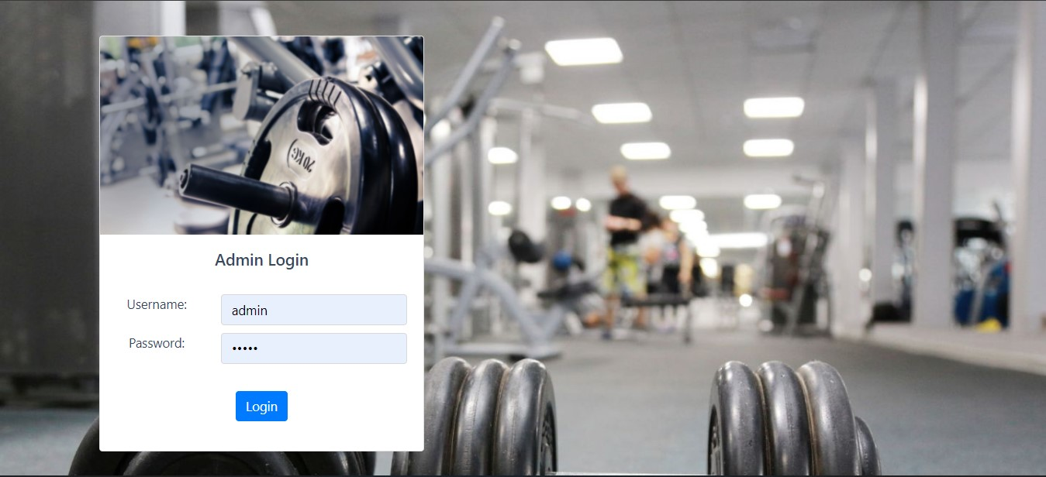

**Admin Page**

So, the admin will have their own username and password. This entity will also record the login time and logout time of the user from the system. Maintaining the record of the time will provide security surveillance over the admin events also. The administrator also has relationships with every entity as it needs to track every performance of the system.

## **User Interface Design**

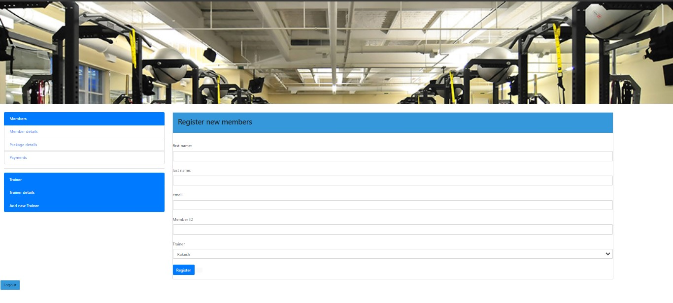 The Gym Management System reduces all the complexity of the conventional method which is a combination of folders, spreadsheets, emails, and for the management of members’ information and payment info. It has a unified system in which all the processes from registration to payment in one system.

### Admin (Administrator):

This actor describes the administration of the gym and the admin are the ones who own the gym. The administration has access to all the information. They can log in through the home screen then there will be options to see the reports about members, trainers, payments, etc. After logging in members and admins have different options like admin have privileges to access anyone’s information where members are limited to their relation.

### Member:

This actor represents the gym members either they are going to register or already registered through the online system. They will have fewer options than the admins as their access is limited.

### Home:

This is the main interface for both administrators and members. Now the member’s home screen has options to either log into the account or creates a new account by registering on the online system. The home screen doesn’t have many options except the usual one like contact information about the gym or about the gym.

The register and login cases are extending the home because they can either these of two or anyone these options.

### Login:

If the user has registered or already a member of the gym, they can open their account by logging in with credentials to have further options on the home screen. The options are extending the login page. After logging in users/members can view their profile or view the reports they generate in the past reports can be the payment information.

### Register:

If there is a new user and wants to become a member they can register through this interface.

### Payment:

If the user logged in and select the available package they want to opt. Then they can make payments through the payment interface. For the payment, the user/member has two options either go offline or online. If the user selects online then there will be a payment gateway where the user can by using debit, credit card, or net banking and after successful payment, the membership will be confirmed.

Where if the user opts for offline then the user has to go to physically to the gym and make payment.

### Trainer-info:

The trainer info is added by the gym owner which is admin and only admin can view that information after logging in with the correct credentials.

### Payment

The payment entity is more important and sensitive than any other entity as it involves fund management. It will store all the information about the fee payment made by the members. This will give transparency between administration and the member that any time member can check their account if it is correctly updated.

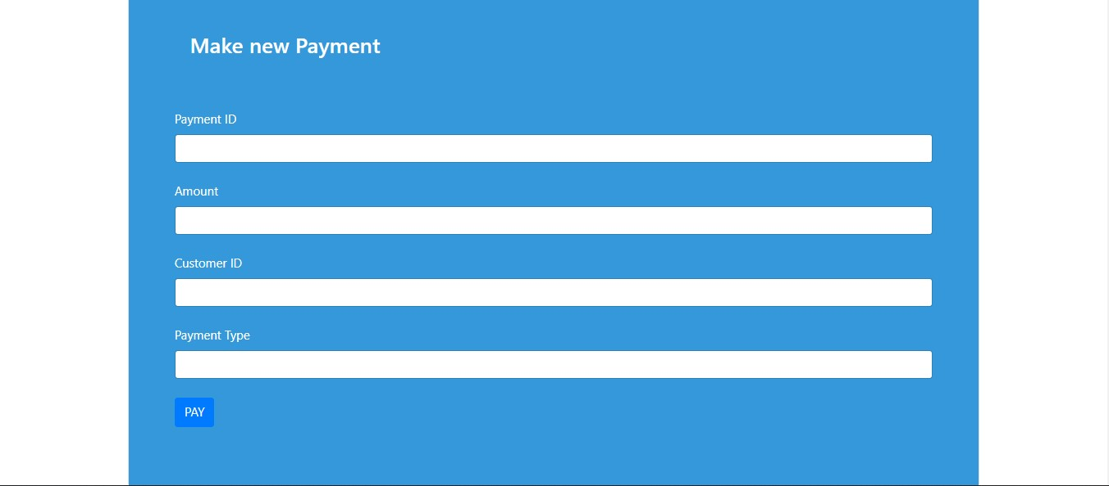

#### Payment-id:

It’s a primary key for this entity. To differentiate between all the transactions and fund transfer it easy with a payment id to differentiate one from another. It will be automatically generated each time there is a transaction.

#### Customer-id:

This attribute stores the member id for which the fee is paid. By storing the member id is easy to find if the fee is due or paid for each member.

#### Amount:

The amount which member has paid in the transaction.

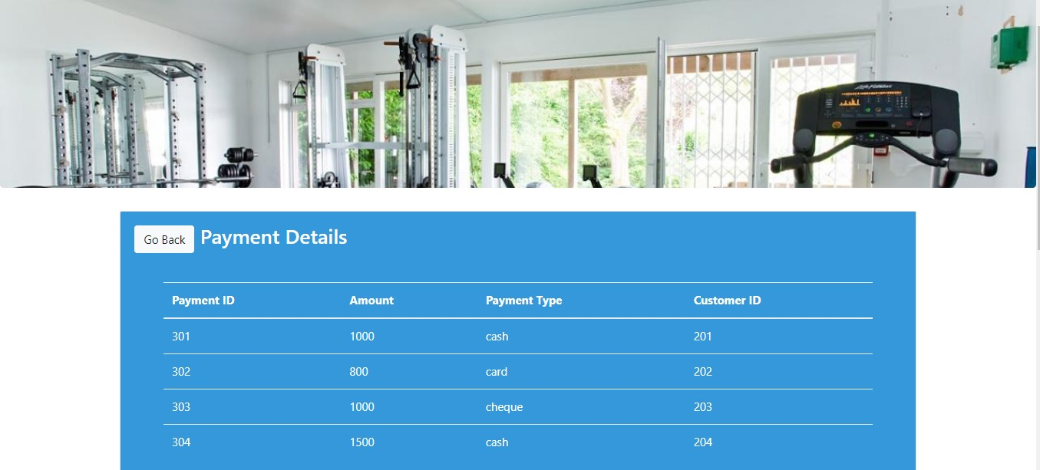

### Members

The essential entity for the system is a member. It will store all the information about the member from personal to gym-related information. It will also store the user status through which the admin can directly find out if the member is allowed like if they have paid their fee. Admin can also update member’s gym information and the member can view by login in with their credentials.

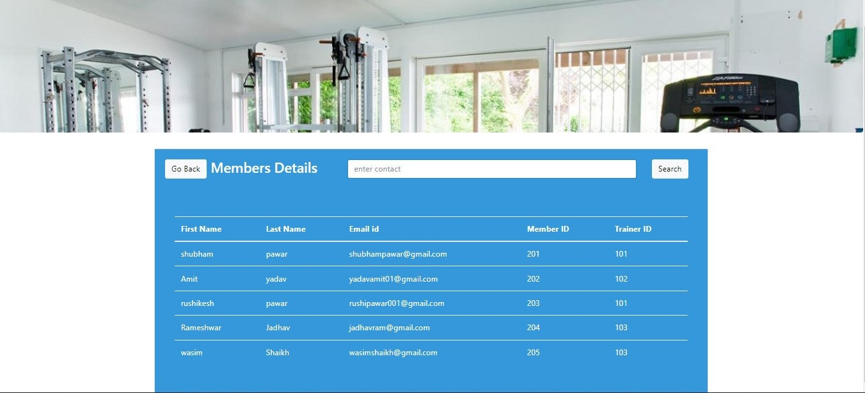

#### Member-id:

It’s a primary key for this entity. This will also act as the username while logging into their account in the system. This member id will be generated automatically and assigned to the member at the time of registration. This will help in uniquely identifying the members.

#### Member-name:

Attribute store name of the member used for identification purpose from a government authorized id card.

#### Member-Email-Id:

The email of the member for any kind of communication with a member or maybe some announcement.

### Trainer

This entity stores the information about the trainer who is hired by the gym administration to train their member to work out correctly. Working out correctly is the same as important as actually working out. This trainer could be hired on basis of hourly charges or special training for the member or they could be on an agreement like a permanent employee of the gym.

#### 

#### Trainer-id:

This is a unique identification number given to each trainer which can also be said that employee id in any other organization. This is the primary key for the entity.

#### Trainer-name:

This attribute stores name of the person for usual identification.

#### Trainer-contact:

It stores the contact number of the trainer for any immediate communication required.

**Registration**

* This section is put into use, when a new user is to add in our website and to create an account with us. In this, we have performed on three fields.

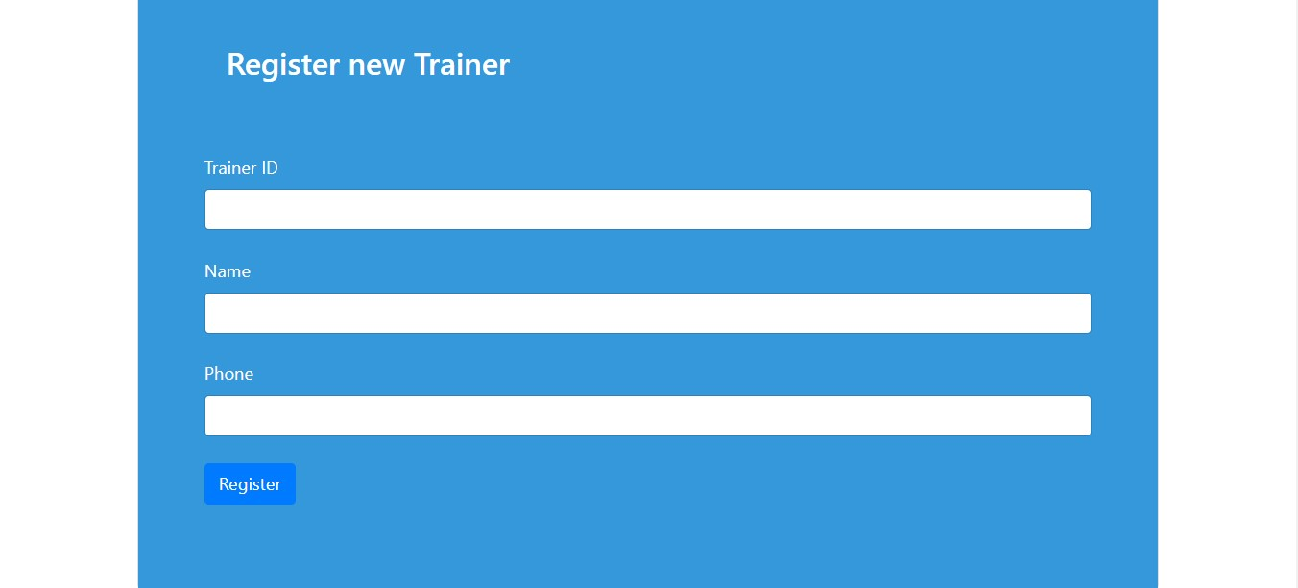

### Trainer-info:

The trainer info is added by the gym owner which is admin and only admin can view that information after logging in with the correct credentials.

#### User-name:

Attribute store name of the user used for identification purpose from a government authorized id card.

**User-contact:**

Attribute store contact number of the user used for identification and to share schedule.

* This section is put into use, when a new member is to add in our website and to create an account with us.

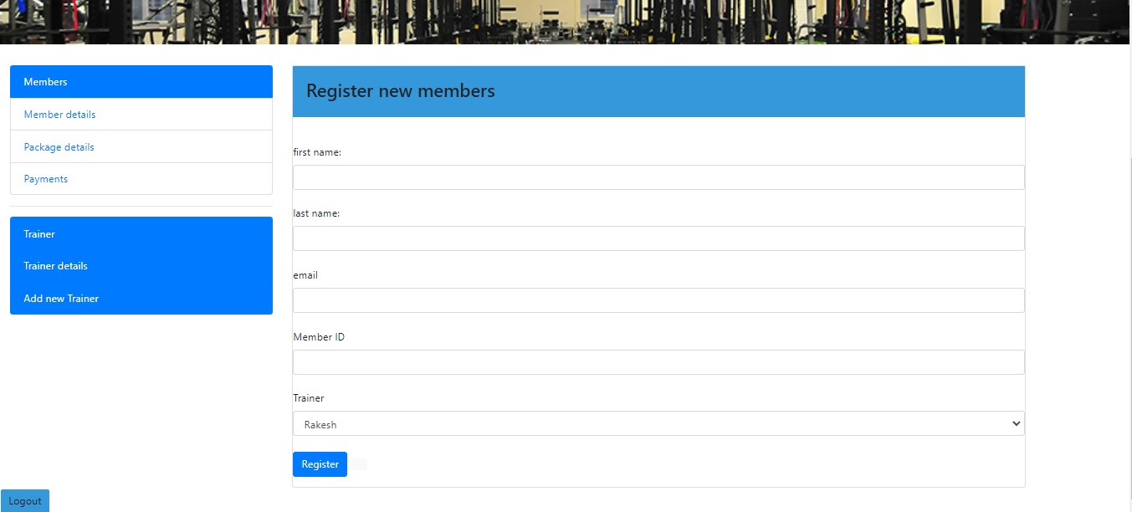

#### Member-id:

This will also act as the username while logging into their account in the system. This member id will be generated automatically and assigned to the member at the time of registration. This will help in uniquely identifying the members.

#### Member-name:

Attribute store name of the member used for identification purpose from a government authorized id card.

#### Member-Email-Id:

The email of the member for any kind of communication with a member or maybe some announcement.

### Trainer-info:

The trainer info is added by the gym owner which is admin and only admin can view that information after logging in with the correct credentials.

**CONCLUSION**

The “**GYM MANAGEMENT SYSTEM**” is successfully designed and developed to fulfilling the necessary requirements, as identified in the requirements analysis phase, such as the system is very much user friendly, form level validation and field level validation are performing very efficiently. The new computerized system was found to be much faster and reliable and user friendly then the existing system, the system has been designed and developed step by step and tested successfully. It eliminates the human error

that are likely to creep in the kind of working in which a bulk quantity of data and calculations as to be processed. The system results in quick retrieval of information that is very vital for the progress any organization. Cost is minimized in case of stationary. Burden of manual work is reduced as whenever transaction takes place, there is a no need to record it in many places manually.

Our project is only a humble venture to satisfy the needs to manage their project

work. Several user friendly coding have also adopted. This package shall prove to be a

powerful package in satisfying all the requirements of the school. The objective of

software planning is to provide a frame work that enables the manger to make

reasonable estimates made within a limited time frame at the beginning of the software

project and should be updated regularly as the project progresses.

At the end it is concluded that we have made effort on following points...

* A description of the background and context of the project and its relation to work

already done in the area.

* Made statement of the aims and objectives of the project.
* The description of Purpose, Scope, and applicability.
* We define the problem on which we are working in the project.
* We describe the requirement Specifications of the system and the actions that

can be done on these things.

* We understand the problem domain and produce a model of the system, which

describes operations that can be performed on the system.

* We included features and operations in detail, including screen layouts.
* We designed user interface and security issues related to system.
* Finally the system is implemented and tested according to test cases.

The objective of this project was to build a program for maintaining the

details of all the members,employees and inventory .The system

developed is able to meet all the basic requirements. The management

of the records (both members and employees)will be also benefited by

the proposed system, as it will automate the whole procedure, which

will reduce the workload. The security of the system is also one of the

prime concerns.

There is always a room for improvement in any software, however

efficient the system may be. The important thing is that the system

should be flexible enough for future modifications. The system has been

factored into different modules to make system adapt to the further

changes. Every effort has been made to cover all user requirements

and make it user friendly.

❑ **Goal achieved:** The System is able provide the interface to the

owner so that he can replicate his desired data. .

❑ **User friendliness:** Though the most part of the system is

supposed to act in the background, efforts have been made to

make the foreground interaction with user(owner) as smooth as

possible. Also the integration of the existing system with the

project has been kept in mind throughout the development

phase.

**Future Scope of the Project:**

In a nutshell, it can be summarized that the future scope of the project circles

around maintaining information regarding:

We can add printer in future. We can give more advance software for Gym Management System including more facilities We will host the platform on online servers to make it accessible worldwide

Integrate multiple load balancers to distribute the loads of the system Create the master and slave database structure to reduce the overload of the

database queries Implement the backup mechanism for taking backup of codebase and database on regular basis on different servers

The above mentioned points are the enhancements which can be done to increase

the applicability and usage of this project. Here we can maintain the records of Gym

and Attendance. Also, as it can be seen that now-a-days the players are versatile, i.e.

so there is a scope for introducing a method to maintain the Gym Management System.

Enhancements can be done to maintain all the Gym, Attendance, Gym Shift, Package,

Trainer.

We have left all the options open so that if there is any other future requirement

in the system by the user for the enhancement of the system then it is possible to

implement them. In the last we would like to thanks all the persons involved in the

development of the system directly or indirectly. We hope that the project will serve its

purpose for which it is develop there by underlining success of process.